
PHENIKAA UNIVERSITY
PHENIKAA SCHOOL OF INFORMATION TECHNOLOGY

COURSE: SOFTWARE REQUIREMENTS

PROJECT TOPIC: FOOTBALL PITCH BOOKING SYSTEM

SOFTWARE REQUIREMENTS SPECIFICATION (SRS)

Lecturer: VU QUANG DUNG

Group 10: HO DIEN HUNG (24107264 – K18-KTPM)
CAN DAI DUONG (24101570– K18-KTPM)
Tran Doan Viet Anh (24100033 - K18-KTPM)

Credit class:
CSE703095-1-1-26(N01)
HANOI, OCTOBER 2026

STT | Full Name | Detailed Work Description | Completion Assessment | Project Contribution Percentage
1 | Ho Dien Hung | Module 06: Matchmaking Engine  Module 07: Dashboard & Analytics  Module 08: Notification & CRM | 10/10 | 33%
2 | Tran Doan Viet Anh | MODULE 01: Auth & User Management  MODULE 02: Field & Slot Management | 10/10 | 33%
3 | Can Dai Duong | MODULE 03: Booking Engine  MODULE 04: Payment Gateway  MODULE 05: POS & Add-on Services | 10/10 | 33%
WORK ASSIGNMENT TABLE

1. INTRODUCTION
1.1. Purpose of the Document
1.2. Document Conventions (ISO/IEC/IEEE 29148:2018 Standard & EARS Syntax)
1.3. System Scope (Sport Court Booking & Management System – SCBS-2026)
1.4. Architectural Overview of 8 Core Modules:
Module 01: Auth & User Management
Module 02: Field & Slot Management
Module 03: Booking Engine
Module 04: Payment Gateway
Module 05: POS & Add-on Services
Module 06: Matchmaking Engine
Module 07: Dashboard & Analytics
Module 08: Nhotification & CRM
2. OVERALL SYSTEM DESCRIPTION
2.1. Product Context & Operational Challenges
2.2. User Classes & Actor Characteristics:
2.2.1. Customer / Team Captain
2.2.2. Court Owner / Pitch Manager
2.2.3. Receptionist / POS Staff
2.2.4. System Administrator
2.2.5. Secondary Actor: Payment Gateways (VNPay / MoMo / VietQR API)
2.2.6. Secondary Actor: Notification Services (Firebase FCM / SMS Gateway)
2.3. Operating Environment & Technical Infrastructure (Flutter Mobile, Node.js NestJS API, PostgreSQL/PostGIS, Redis Lock)
2.4. Design and Implementation Constraints (ISO/IEC 27001 Security, PCI-DSS Compliance)
2.5. System Assumptions and Dependencies
3. GLOSSARY & ABBREVIATIONS
4. DETAILED SPECIFICATIONS OF 8 MODULES & FUNCTIONAL REQUIREMENTS (FRs & USE CASES)
4.1. Overview Matrix of Functional Requirements (FRs) & Use Case Catalog
4.2. MODULE 01: Auth & User Management
4.2.1. Multi-factor Registration & Authentication (SMS OTP, Google, Apple ID, Facebook)
4.2.2. Secure Authentication (JWT, Refresh Token, Session Control) & Role-Based Access Control (RBAC)
4.2.3. User Profile Management, Team Roster & Activity Logs
4.3. MODULE 02: Field & Slot Management
4.3.1. Digitalization of Court Complexes, Category Configuration & Maintenance Tracking
4.3.2. Flexible Dynamic Pricing Configurations (Peak/Off-peak Hours, Special Events, Court Types)
4.3.3. Slot Mapping Management & Parent-Child Court Collision Locking Mechanisms
4.4. MODULE 03: Booking Engine
4.4.1. Real-time Slot Lookup & Geo-location GPS Court Discovery
4.4.2. Real-time Temporary Slot Holding (10-minute Hold) & Overbooking Prevention (Distributed Redis Lock)
4.4.3. Single Booking & Recurring Long-term / Weekly Fixed Slot Bookings
4.5. MODULE 04: Payment Gateway
4.5.1. Multi-channel Payment Integration (Dynamic VietQR, E-Wallets, ATM/Credit Cards)
4.5.2. Automated Payment Webhook Verification & Anti-duplication (Idempotency)
4.5.3. Deposit Workflow, Tiered Cancellation Policies, Wallet Refunds & Automatic Slot Release
4.6. MODULE 05: POS & Add-on Services
4.6.1. POS Counter Check-in Interface & On-site Remaining Balance Collection
4.6.2. Catalog & Sales Management for Add-on Services (Beverages, Equipment Rental, Bibs, Access
4.6.3. Inventory Tracking & Automatic Invoice Bundling
4.7. MODULE 06: Matchmaking Engine
4.7.1. Match Post Creation & Opponent Finding from Confirmed Bookings
4.7.2. Match Search Filtering by Proximity Radius, Skill Level & Time Slots
4.7.3. Match Requests, Applicant Approval, Communication Channels & Split Deposit Processing
4.8. MODULE 07: Dashboard & Analytics
4.8.1. Comprehensive Financial Reporting (Court Revenue, POS Sales, Deposit/Refund Cashflows)
4.8.2. Operational Analytics & Occupancy Rate Heatmap
4.8.3. No-show Rate Tracking & Reception Shift Reconciliation
4.9. MODULE 08: Notification & CRM
4.9.1. Automated Push & SMS Notifications (Deposit Confirmations, Reminders at t - 2 Hours with Google Maps)
4.9.2. Customer Loyalty Tiering, Reward Points & Voucher/Coupon Management
4.9.3. No-show Penalty Enforcement, Automated Booking Restrictions & Dispute Ticket Resolution
5. DATA REQUIREMENTS AND DATABASE MANAGEMENT
5.1. Entity Analysis Across 8 Core Modules (Entities & Relationships)5.2. Complete System ERD (Database Schema for PostgreSQL/PostGIS & Redis)
5.3. Data Integrity Constraints & Audit Trail Logging Strategy
6. QUALITY ATTRIBUTES (12 NON-FUNCTIONAL REQUIREMENTS – NFRs)
6.1. Usability & Mobile UI/UX (NFR-03, NFR-04, NFR-12)
100% Responsive Flutter Card View UI (4.7–6.7 inches), Real-time Synchronization < 1s.
6.2. Performance & Scalability (NFR-01, NFR-05, NFR-08)
Push Notification Response < 2s; Search API/Dashboard Load < 300ms at 1,000 CCU.
6.3. Security & Privacy (NFR-03, NFR-04, NFR-07, NFR-10)
SSL/TLS 1.2+ Encryption, Phone Number Masking prior to match approval, HMAC-SHA256 Encrypted Check-in QR Codes.
6.4. Data Safety & Concurrency Control (NFR-02, NFR-06, NFR-09, NFR-11)
Distributed Redis Locks handling 50 requests/ms to prevent double-booking; Payment Webhook Idempotency; Cronjobs sweeping every 5 minutes.

7. LOCALIZATION AND INTERNATIONALIZATION (I18N)
7.1. Multi-language Support (Vietnamese / English)
7.2. Timezone Formatting (UTC+7), Currency (VND), and Google Maps Vietnam Integration
8. CHANGE AND RISK MANAGEMENT
8.1. Change Request Management (CR-01 to CR-06)
8.2. System Risk Assessment & Mitigation Strategies (HZ-01 to HZ-07)

  - 1. INTRODUCTION
  - 1.1. Purpose of the Document
  - This document aims to describe and specify in detail the technical, business, and non-functional requirements, as well as the use cases, for the Sport Court Booking & Management System (SCBS-2026).
  - Specifically, the document serves the following core purposes:
  - - Establishing a common basis for communication: Clearly defining the system's scope, functionality, and business rules among the Software Engineering Team, Court Owners, and end customers (Customers).
  - - Guiding system design and development: Providing foundational information for software engineers, testers, and system analysts to design the database structure, develop APIs, implement user interfaces, and create automated test scenarios using pytest.
  - - Ensuring traceability: Establishing clear links between real-world requirements elicitation sessions (elicitation_sessions), the Functional Requirements (FRs), Non-Functional Requirements (NFRs), hazard analyses, and specific test cases. This traceability supports effective change control through the Change Request management process.
  - 1.2. Document Conventions
  - To ensure consistency, readability, and standardization throughout this technical document, the following formatting and syntax conventions are applied:
  - - Requirements specification syntax: Functional requirements are specified using the EARS (Easy Approach to Requirements Syntax) approach, which helps distinguish triggering conditions, actors, and system behavior. For example: “When [condition], the system shall [behavior].”
  - - Identifier conventions: The following identifiers are used consistently throughout the document:
  - FR-x.y.z: Functional Requirement.
  - NFR-xx: Non-Functional Requirement.
  - UC-xx: Use Case.
  - STK-xx: Stakeholder.
  - TC-xx: Test Case.
  - HZ-xx / HAZ-xx: System Hazard and Risk.
  - CR-xx: Change Request.

  - Technical Terminology: Technical terms related to technology, concurrency locking, QR code encryption (HMAC-SHA256), payment gateways, and deposit refund/forfeiture policies are retained in their original English form or explicitly defined in Section 3 of this document.
  - 1.3. Project Scope (Sport Court Booking & Management System – SCBS-2026)
  - The SCBS-2026 system is a web-based online sports court booking and management platform designed to optimize operational processes for popular sports, including badminton, football (5-a-side, 7-a-side, and 11-a-side), and similar sports facilities.
  - In-Scope:
  - Search and Discovery: Enables customers to search for available courts by facility, date and time, court type, and price, with low response latency (p95 ≤ 2 seconds).
  - Online Booking and Payment: Provides a temporary reservation mechanism (a 10-minute Hold Window), integrates with payment gateways to process deposits, generates unique booking confirmation codes, and prevents double bookings.
  - Cancellation Policy Management and Automatic Refunds: Automatically calculates cancellation timing based on the court's local time zone to apply business rules for deposit refunds or forfeitures. These include a 100% deposit refund for standard-time bookings canceled at least 24 hours in advance, or deposit forfeiture for peak-hour bookings canceled within 12 hours, in accordance with business rules BR-01 and BR-02.
  - Court Administration and Pricing Configuration: Allows court owners to manage schedules, define peak-hour periods, configure dynamic pricing, and set additional charges for holidays and weekends.
  - Smart Check-in: Supports scanning securely encrypted QR codes using HMAC-SHA256 at the facility to verify customers and activate the automated lighting system.
  - Dispute Resolution and Auditing: Provides administrators with a module for reviewing complaints, processing exceptional refunds, and maintaining a 100% audit log of changes to sensitive configurations.

- Out-of-Scope:
  - Construction or physical development of sports facilities and their infrastructure.
  - In-house development of payment gateway hardware. The system uses standardized third-party payment gateways integrated through APIs and webhooks.
  - Integration with external Enterprise Resource Planning (ERP) systems or advanced accounting systems.
  - Management of large-scale marketing campaigns or implementation of complex biometric identity verification.

  - 2. OVERALL DESCRIPTION
  - 2.1. Product Perspective
  - As public interest in physical fitness and healthy lifestyles continues to grow, the demand for renting sports facilities for activities such as badminton and football (5-a-side, 7-a-side, and 11-a-side) in urban areas and educational institutions has increased significantly. However, traditional management practices at most sports facilities still rely heavily on manual records, social media messages, or direct telephone calls. These methods lead to several significant problems, including double booking caused by scheduling conflicts, a lack of transparency in deposit collection and cancellation policies, difficulties for court owners in managing peak-hour schedules, and the considerable time customers spend searching for suitable available courts.
  - To address these challenges comprehensively, the Sport Court Booking & Management System (SCBS-2026) is developed as an integrated web-based solution. The system automates the entire process, from court search and temporary reservation holds to online payments, schedule management, real-time application of deposit refund and forfeiture policies, QR-code check-in at sports facilities, and dispute resolution. SCBS-2026 promotes transparency and fairness for players, optimizes revenue for court owners, and improves overall operational management efficiency.
  - 2.2. User Classes and Characteristics
  - The system identifies five primary user groups, including direct users and integrated external systems, each with specific roles, characteristics, and permissions.
  - Customer (STK-01 / ACT-01):
  - Characteristics: Individuals or groups of football or badminton players who need to search for courts, make bookings, pay deposits, cancel reservations, or submit complaints and dispute requests when necessary.
  - Requirements: An intuitive user interface, fast court-search performance, a simple booking process, immediate booking confirmation notifications, and support for recurring monthly bookings.
  - Court Owner / Venue Manager (STK-02 / ACT-02):
  - Characteristics: Individuals or organizations that own and operate sports facilities.
  - Requirements: Flexible management tools for updating court listings, configuring operating hours, setting base prices, defining peak-hour rules, configuring weekend and public-holiday surcharges, and monitoring the actual utilization status of sports courts.
  - System Administrator (STK-03 / ACT-03):
- Responsibilities: Manage user accounts; establish and modify system-wide business rules (BR-xx); receive and resolve customer dispute tickets; approve exceptional refund requests; and monitor all system audit logs.
- Electronic Payment Gateway (STK-07 / ACT-04):
- Characteristics: A third-party intermediary payment service, such as VNPay, MoMo, or Stripe.
- Requirements: Securely process deposit payments, execute refund requests, or record deposit forfeitures based on authenticated callbacks and webhooks sent to the system.
- Notification Service (ACT-05):
- Characteristics: An integrated internal and external service responsible for delivering notifications.
- Requirements: Automatically receive system events, such as successful booking confirmations, booking cancellations, and dispute status changes, and deliver notifications to users via email, SMS, or push notifications.
- 2.3. Operating Environment
- The SCBS-2026 system is designed and deployed in a modern technological environment to ensure high availability and flexible accessibility.
- Application Platform: Operates as a responsive web application, providing compatibility with widely used modern web browsers on desktop computers, including Chrome, Firefox, Safari, and Edge, as well as mobile devices such as smartphones and tablets.
- Server Infrastructure and Storage: Runs in a cloud server environment with a relational database management system that supports ACID transactions to prevent data conflicts caused by concurrent operations.
- Time Zone and Time Standards: All timestamps stored in the database are standardized to UTC. However, timestamps are displayed in the user interface according to Vietnam's local time zone, Asia/Ho_Chi_Minh, to ensure accurate cancellation deadline calculations and prevent time zone-related conflicts.
- External Connectivity: Depends on a stable Internet connection and reliable API/webhook communication with the Electronic Payment Gateway and Notification Service.
- 2.4. Design and Implementation Constraints
- The design, development, and documentation of the SCBS-2026 system must strictly comply with the following technical standards and requirements:
- Tiêu chuẩn kỹ nghệ phần mềm: Toàn bộ tài liệu đặc tả yêu cầu được biên soạn theo chuẩn quốc tế ISO/IEC/IEEE 29148:2018 (Systems and software engineering — Life cycle processes — Requirements engineering).
- Requirements Specification Syntax: All Functional Requirements (FRs) must be written using the standard EARS (Easy Approach to Requirements Syntax) syntax to ensure clarity, eliminate ambiguity, and enable direct verification.
- Software Architecture Constraints:
  - The system shall implement a concurrency locking mechanism (Concurrency Lock / Soft-lock mechanism) to prevent two customers from successfully booking the same time slot simultaneously.
- The system must incorporate data integrity checks for parent–child court relationships (e.g., an 11-a-side football pitch containing smaller 5-a-side pitches) to prevent physical scheduling conflicts when renting these facilities.
- On-site check-in QR codes must be securely protected using the HMAC-SHA256 standard, together with an automatic secret key rotation mechanism, to prevent QR code forgery and replay attacks.
- 2.5. Assumptions and Dependencies
- Throughout the analysis, design, and operation of the SCBS-2026 system, the following core assumptions and dependencies are established:
- Users and Devices: It is assumed that all customers and court owners have devices with stable Internet connectivity, use up-to-date web browsers, and provide accurate contact information (email addresses and phone numbers) to receive system notifications.
- Payment Gateway: The system depends on the availability, security, and real-time responsiveness of third-party payment gateways. It is assumed that the payment gateway provides reliable webhook/callback mechanisms with secure signature verification to communicate the success or failure status of deposit payments and refunds.
- Initial Operational Data: It is assumed that the initial configuration data, including court listings, court layouts, operating time zones, and standard pricing, provided by court owners is accurate and regularly updated by authorized personnel.
- System Clock: The system depends on a synchronized time source, such as an NTP server, to accurately manage the 10-minute temporary reservation countdown and calculate deposit-forfeiture cancellation deadlines fairly and consistently.
- 3. GLOSSARY & ABBREVIATIONS
Term / Acronym | Definition & Contextual Meaning
SCBS | Sport Court Booking System - Modular enterprise platform for pitch reservations.
ISO/IEC/IEEE 29148:2018 | International standard for software and systems requirements engineering processes.
EARS | Easy Approach to Requirements Syntax - standard format for unambiguous requirements.
RBAC | Role-Based Access Control - 4-role hierarchy: Customer, Pitch Staff, Field Owner, Admin.
JWT | JSON Web Token - RFC 7519 Bearer token with Access Token (15m) and Refresh Token (7d).
OTP / ZNS | One-Time Password delivered via SMS Gateway or Zalo Notification Service with 120s TTL.
Redis Soft-Lock | Distributed locking mechanism (SETNX with TTL=600s) preventing concurrent double booking.
Parent-Child Court | Spatial hierarchy where 1 Pitch 11 encompasses 3 Pitch 5 sub-courts with collision locking.
Dynamic Pricing | Real-time pricing engine factoring peak hours (16:00-22:00), weekends, holidays, and coupons.
No-Show Strike | Disciplinary tracking rule: 3 no-shows within 30 days requires mandatory 100% upfront deposit.
HMAC-SHA256 QR | Tamper-proof cryptographic token generated upon booking confirmation for physical on-site check-in.

4. DETAILED SPECIFICATIONS OF 8 MODULES & FUNCTIONAL REQUIREMENTS (FRs & USE CASES)
4.1. Overview Matrix of Functional Requirements (FRs) & Use Case Catalo
Module ID | Module Designation | Core Architectural Scope
MODULE 01 | Auth & User Management | Multi-factor Registration & Authentication, Secure JWT / RBAC, Profile & Activity Logs.
MODULE 02 | Field & Slot Management | Court Complex Digitalization, Category & Maintenance, Dynamic Pricing, Slot Mapping & Collision Locking.
MODULE 03 | Booking Engine & Multi-court Checkout | Cart reservation checkout, multi-pitch bundling, and recurring schedule reservations (Out-of-Scope, unassigned).
MODULE 04 | Payment Gateway & Escrow Settlement | Integration of VNPay/MoMo/ZaloPay IPN webhooks, deposit settlement & automated refunding (Out-of-Scope, unassigned).
MODULE 05 | On-site POS & Auxiliary Add-on Services | On-site reception billing, beverage and bibs rental POS, stock inventory control (Out-of-Scope, unassigned).
MODULE 06 | Opponent Matchmaking & Community Engine | Amateur matchmaking lobby, player skill ranking badges, team finding chat (Out-of-Scope, unassigned).
MODULE 07 | Dashboard Analytics & Business Intelligence | RevPAH metrics, pitch utilization heatmaps, owner revenue analytics & no-show reports (Out-of-Scope, unassigned).
MODULE 08 | Notification Engine & Customer CRM | Zalo ZNS / SMS automated reminders, calendar sync, push alerts & no-show penalty enforcement (Out-of-Scope, unassigned).
Module 01 & Module 02 (FR-01 to FR-16):
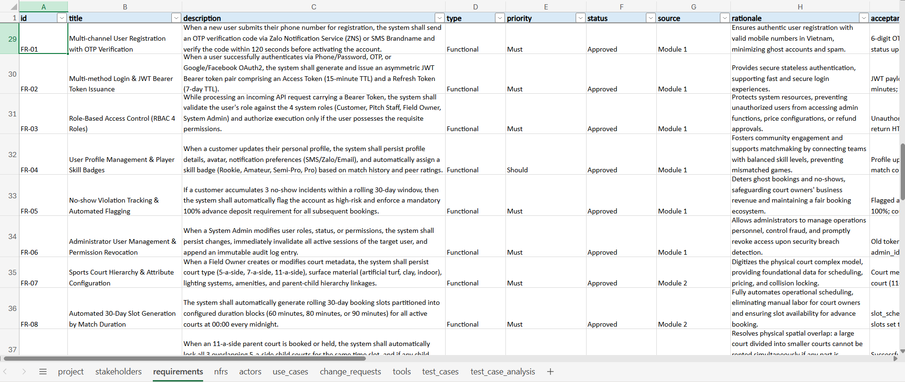
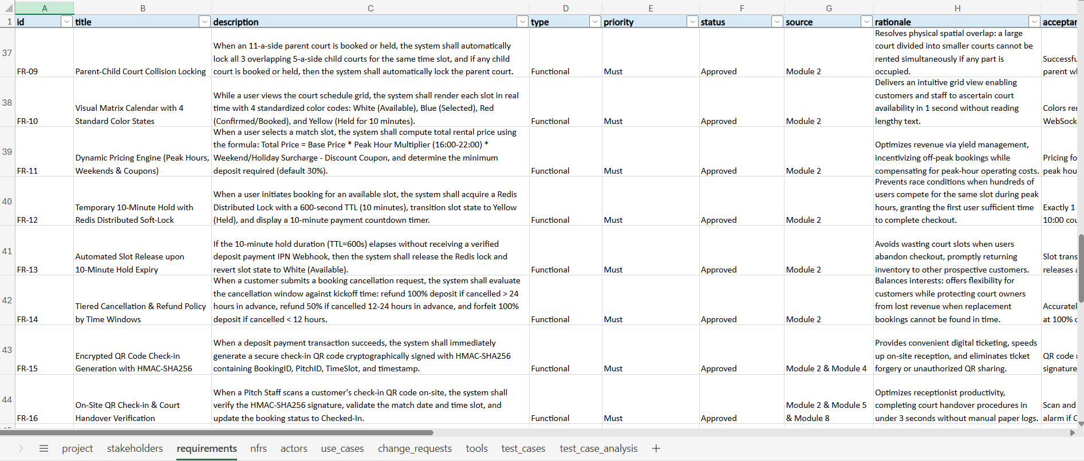
Module 3, Module 4 & Module 5 (FR-03.1 to FR-05.4):
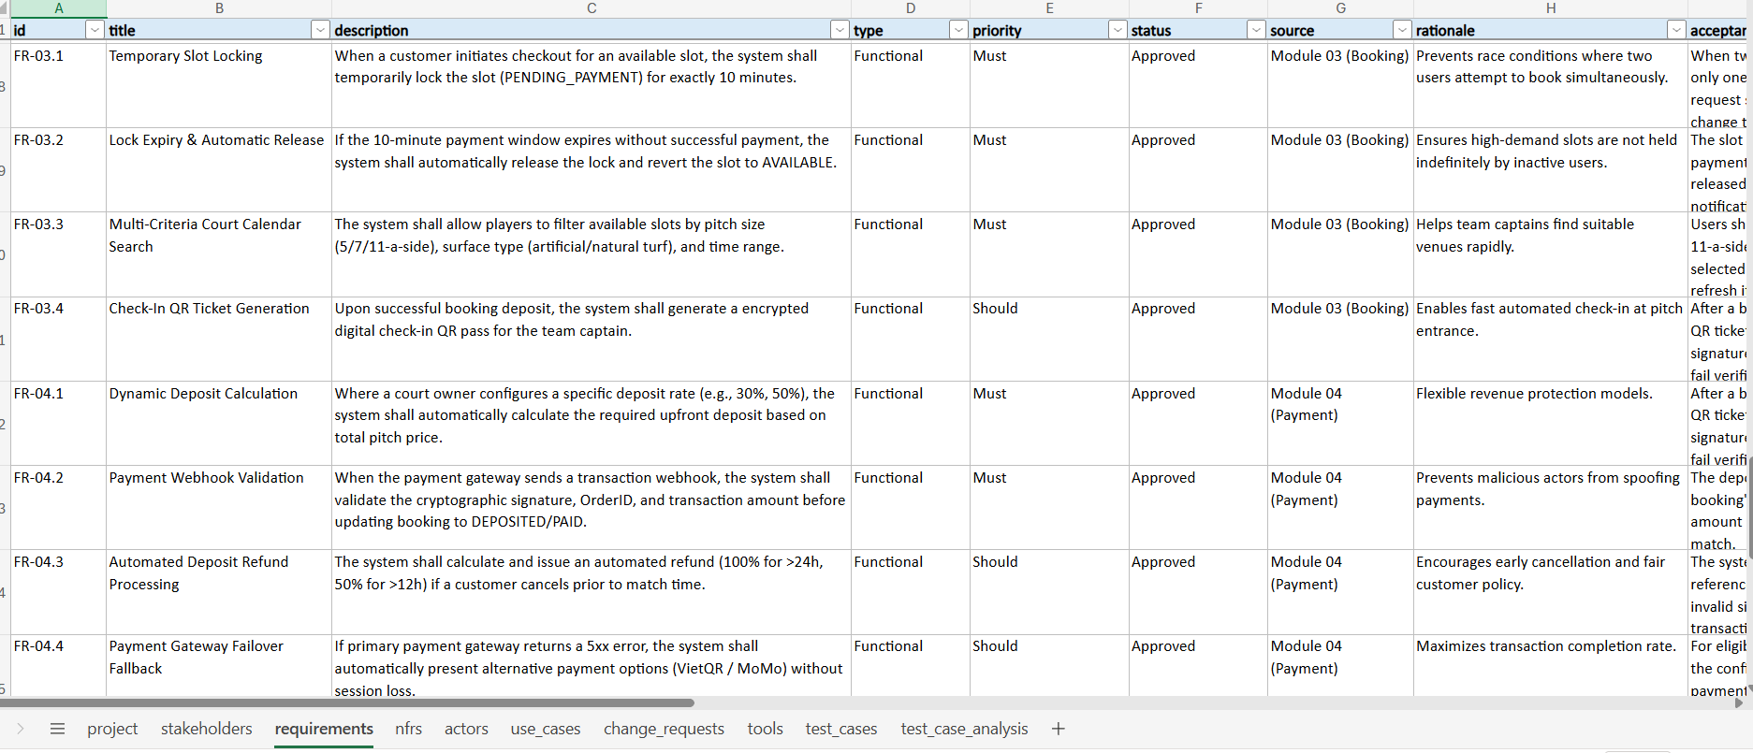
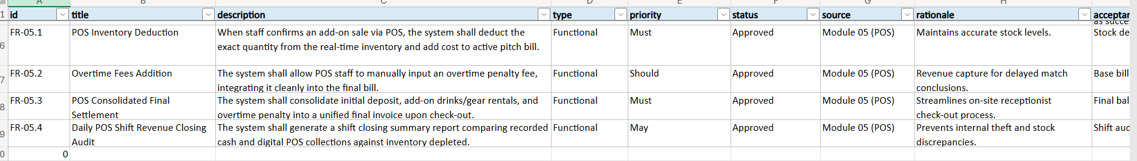
Module 6, Module 7 & Module 8 (FR-01 to FR-24):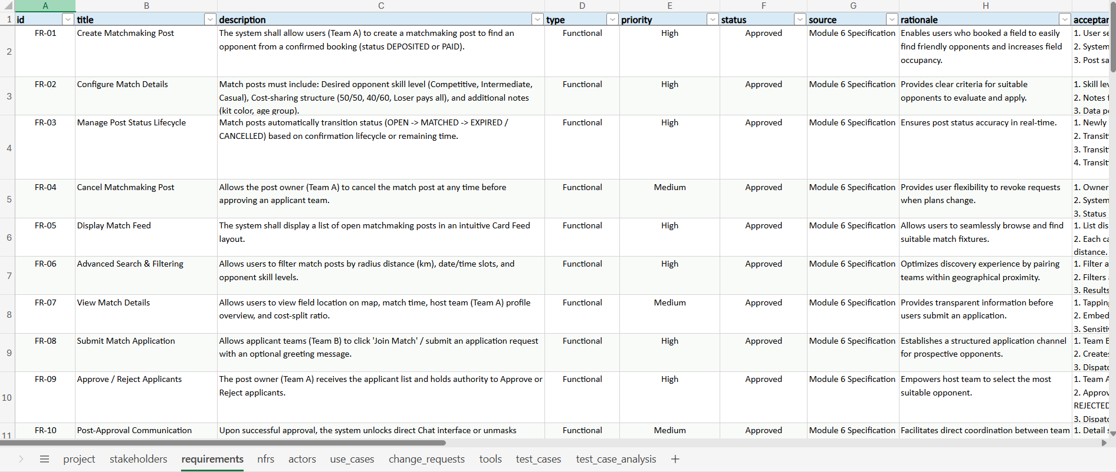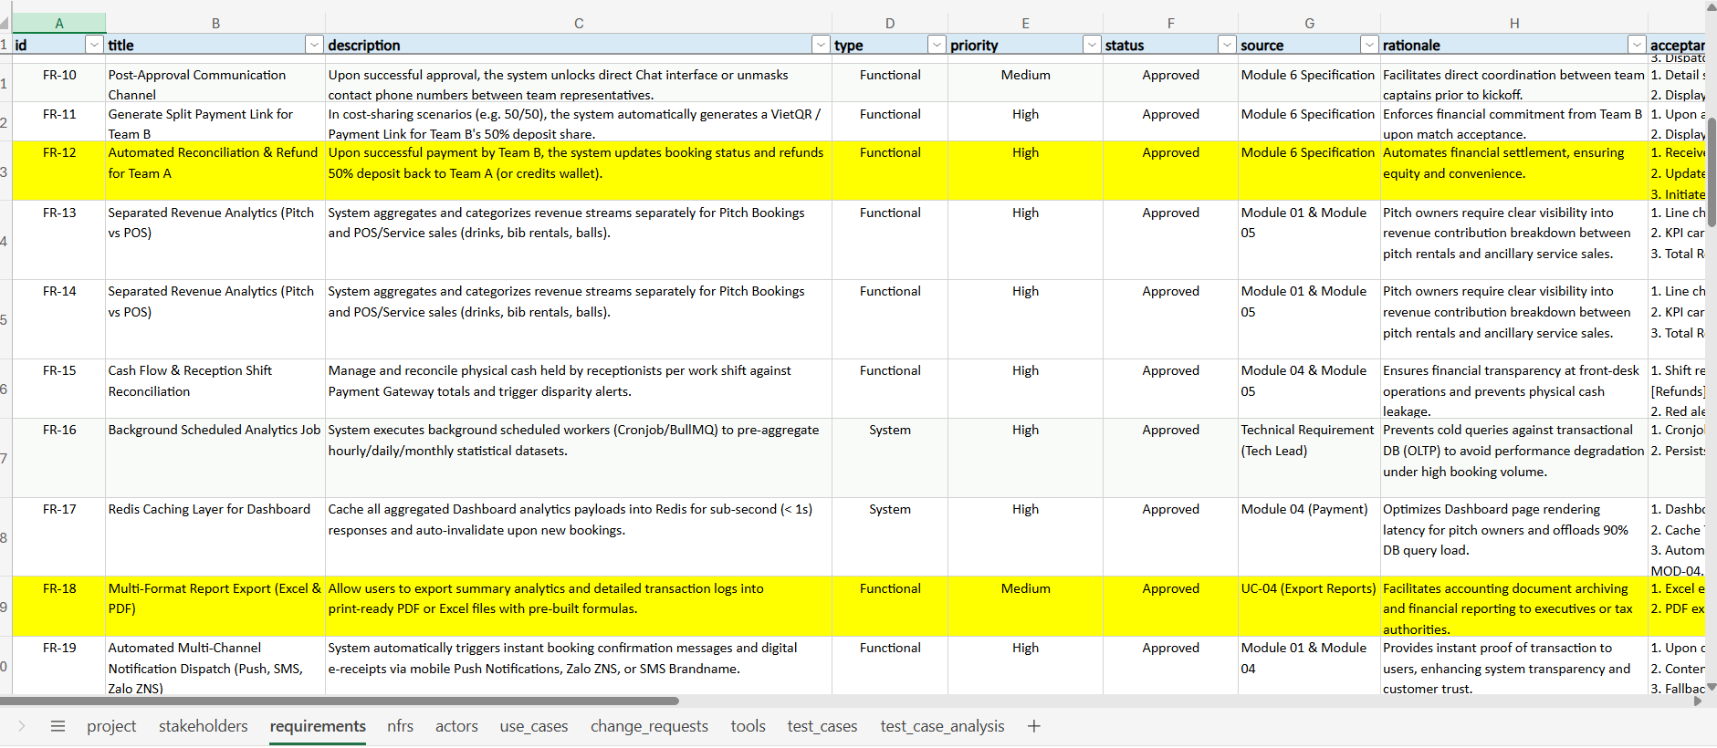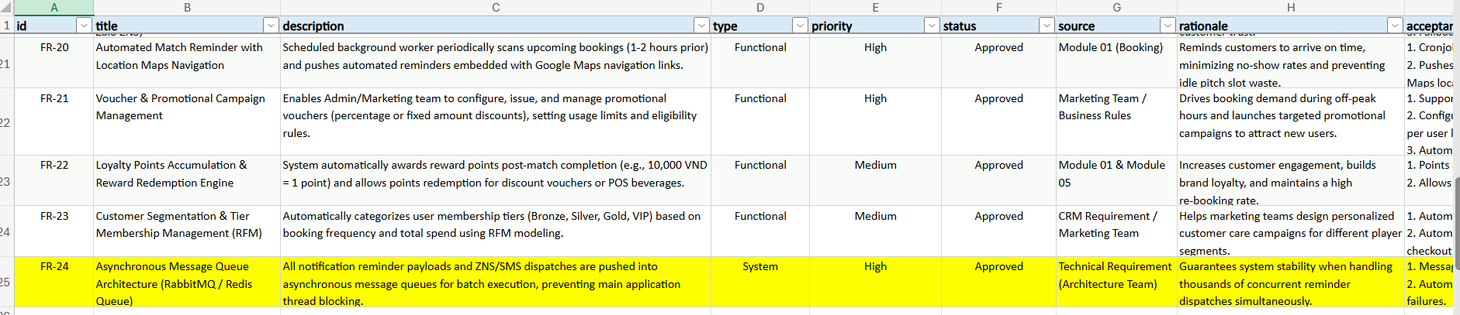
4.2. MODULE 01: Auth & User Management
4.2.1. Multi-factor Registration & Authentication (SMS OTP, Google, Apple ID, Facebook)
Multi-Factor Onboarding: When a new customer or pitch operator registers on the SCBS platform, the system requires verified mobile number validation via 6-digit OTP dispatched through Zalo Notification Service (ZNS) or SMS Brandname with a strict 120-second timeout window (FR-01).
Social OAuth Integration: In addition to credential-based phone/password registration, the platform supports streamlined 1-click authentication via Google OAuth2, Apple ID, and Facebook Login. Incoming OAuth identity tokens are cryptographically validated against provider public key sets, automatically mapped to internal user IDs, and provisioned with standard Customer role privileges.
Verification: Verified by automated Pytest test cases TC-01 (Happy path OTP registration) and TC-02 (Boundary timeout expiration at 120s).
4.2.2. Secure Authentication (JWT, Refresh Token, Session Control) & Role-Based Access Control (RBAC)
Cryptographic Token Issuance (FR-02): Upon successful credential or OAuth authentication, the authorization server issues an asymmetric JWT Bearer token pair comprising a short-lived Access Token (15-minute TTL) and a securely stored Refresh Token (7-day TTL).
Role-Based Access Control Hierarchy (FR-03): System implements strict middleware role verification across 4 system roles: Customer, Pitch Staff, Field Owner, and System Admin. Unauthorized endpoint access attempts immediately yield HTTP 403 Forbidden.
Session Control & Administrator Revocation (FR-06): When a System Admin suspends an account, active Refresh Tokens are added to the Redis blacklist cluster, immediately terminating active sessions across all devices.
Verification: Verified by automated Pytest test cases TC-03 (JWT Token Issuance), TC-04 (RBAC Permission Barrier), and TC-07 (Admin User Revocation & Token Blacklist).
4.2.3. User Profile Management, Team Roster & Activity Logs
Customer Profile & Skill Badges (FR-04): Customers manage personal bios, contact preferences (SMS/Zalo/Email), preferred pitch positions, and team rosters. The system computes dynamic skill ratings and awards transparent badges (Rookie, Amateur, Semi-Pro, Pro) based on match frequency and sportsmanship scores.
No-Show Tracking & Penalization (FR-05): System automatically monitors attendance reliability. Accumulating 3 unexcused no-show incidents within a 30-day window triggers an automated High-Risk account flag, mandating 100% advance deposit for future bookings.
Activity Audit Trail: All significant customer profile modifications, team roster updates, and operational logins are recorded in immutable audit logs.
Verification: Verified by automated Pytest test cases TC-05 (Profile & Skill Badges) and TC-06 (No-Show Violation Tracking & Automated Flagging).
Module 01 EARS Requirements Specifications (FR-01 to FR-06)
Requirement: FR-01: Multi-channel User Registration with OTP Verification
EARS Specification: When a new user submits their phone number for registration, the system shall send an OTP verification code via Zalo Notification Service (ZNS) or SMS Brandname and verify the code within 120 seconds before activating the account.
Rationale: Ensures authentic user registration with valid mobile numbers in Vietnam, minimizing ghost accounts and spam. | Complexity: Low | Verification: Test
Acceptance Criteria: 6-digit OTP delivered in < 5s; OTP expires after 120s; account persisted with Active status upon successful verification.
Requirement: FR-02: Multi-method Login & JWT Bearer Token Issuance
EARS Specification: When a user successfully authenticates via Phone/Password, OTP, or Google/Facebook OAuth2, the system shall generate and issue an asymmetric JWT Bearer token pair comprising an Access Token (15-minute TTL) and a Refresh Token (7-day TTL).
Rationale: Provides secure stateless authentication, supporting fast and secure login experiences. | Complexity: Medium | Verification: Test
Acceptance Criteria: JWT payload contains user_id, role, permissions; Access Token expires in exactly 15 minutes; Refresh Token stored securely for renewal.
Requirement: FR-03: Role-Based Access Control (RBAC 4 Roles)
EARS Specification: While processing an incoming API request carrying a Bearer Token, the system shall validate the user's role against the 4 system roles (Customer, Pitch Staff, Field Owner, System Admin) and authorize execution only if the user possesses the requisite permissions.
Rationale: Protects system resources, preventing unauthorized users from accessing admin functions, price configurations, or refund approvals. | Complexity: Medium | Verification: Test
Acceptance Criteria: Unauthorized requests rejected with HTTP 403 Forbidden; missing or expired tokens return HTTP 401 Unauthorized.
Requirement: FR-04: User Profile Management & Player Skill Badges
EARS Specification: When a customer updates their personal profile, the system shall persist profile details, avatar, notification preferences (SMS/Zalo/Email), and automatically assign a skill badge (Rookie, Amateur, Semi-Pro, Pro) based on match history and peer ratings.
Rationale: Fosters community engagement and supports matchmaking by connecting teams with balanced skill levels, preventing mismatched games. | Complexity: Low | Verification: Test
Acceptance Criteria: Profile updates immediately; badge prominently displayed on avatar and profile with match count and star rating.
Requirement: FR-05: No-show Violation Tracking & Automated Flagging
EARS Specification: If a customer accumulates 3 no-show incidents within a rolling 30-day window, then the system shall automatically flag the account as high-risk and enforce a mandatory 100% advance deposit requirement for all subsequent bookings.
Rationale: Deters ghost bookings and no-shows, safeguarding court owners' business revenue and maintaining a fair booking ecosystem. | Complexity: Medium | Verification: Test
Acceptance Criteria: Flagged accounts display red warning; required_deposit_rate automatically set to 100%; court owners permitted to decline unpaid holds.
Requirement: FR-06: Administrator User Management & Permission Revocation
EARS Specification: When a System Admin modifies user roles, status, or permissions, the system shall persist changes, immediately invalidate all active sessions of the target user, and append an immutable audit log entry.
Rationale: Allows administrators to manage operations personnel, control fraud, and promptly revoke access upon security breach detection. | Complexity: Low | Verification: Test
Acceptance Criteria: Old tokens of suspended accounts immediately blacklisted in Redis; audit log records admin_id, target_user, action, timestamp.
Module 01 Use Cases Specification (UC-01, UC-04)
Attribute | Specification Details
Use Case ID / Title | UC-01 - User Registration with OTP Verification
Primary Actor | Customer
Business Goal | Register a new user account using a genuine phone number to participate in the booking system.
Preconditions | User does not have an active registered account with this phone number.
Main Flow | 1. User submits mobile number and password; 2. System dispatches 6-digit OTP via Zalo ZNS or SMS; 3. User inputs received OTP; 4. System verifies OTP; 5. System activates user account and navigates to login.
Alternative Flows | 4a. Invalid OTP -> System displays error notice; 4b. OTP expired after 120s -> System invalidates code and enables 'Resend OTP'.
Postconditions | New user account created in database with Active status.
Related Requirements | FR-01;NFR-04

Attribute | Specification Details
Use Case ID / Title | UC-04 - User Account Administration & RBAC Role Assignment
Primary Actor | System Admin
Business Goal | Administer user lifecycle, assign 4 system roles, and revoke compromised accounts.
Preconditions | User is authenticated with System Admin role.
Main Flow | 1. Admin opens user management console; 2. Filters and selects target account; 3. Updates role (Customer/Staff/Owner/Admin) or suspends account; 4. System persists changes and revokes active tokens; 5. Records immutable audit log.
Alternative Flows | 3a. Admin attempts to demote own account -> System rejects operation with warning.
Postconditions | User permissions immediately updated across all subsequent API calls.
Related Requirements | FR-03;FR-06;NFR-03

4.3. MODULE 02: Field & Slot Management
4.3.1. Digitalization of Court Complexes, Category Configuration & Maintenance Tracking
Court Complex Hierarchy (FR-07): Enables pitch owners to configure digital court inventories with granular physical attributes: court format (5-a-side, 7-a-side, 11-a-side), surface material (FIFA standard artificial turf, clay, indoor parquet), lighting quality, and child sub-court spatial boundaries.
Automated Slot Generation (FR-08): At 00:00 every midnight, the backend scheduler automatically generates rolling 30-day booking slots partitioned into configured duration blocks (60, 80, or 90 minutes) across all active courts.
Maintenance Blackout Scheduling: Proprietors can flag specific pitches for maintenance downtime, immediately suppressing affected slots from customer search indexes.
Verification: Verified by automated Pytest test cases TC-08 (Court Hierarchy Configuration) and TC-09 (Auto Slot Generation 30 Days).
4.3.2. Flexible Dynamic Pricing Configurations (Peak/Off-peak Hours, Special Events, Court Types)
Dynamic Pricing Calculation Engine (FR-11): Real-time rental rate is computed via multi-variable formula:
Total Price = Base Hourly Rate * Peak-Hour Multiplier (16:00-22:00, default 1.30) * Weekend Surcharge (default 1.15) - Discount Coupon.
Deposit Ratio Rules: Automatically establishes minimum advance deposit (default 30% for standard hours, scalable to 50% for peak/holiday blocks).
Tiered Cancellation & Refund Policy (FR-14): Evaluates cancellation requests against kickoff time: > 24 hours (100% refund), 12 to 24 hours (50% refund), and < 12 hours (0% refund - full deposit forfeiture to protect field owner revenues).
Verification: Verified by automated Pytest test cases TC-13 (Dynamic Pricing Calculation), TC-16 (Refund >24h 100%), TC-17 (Refund 12-24h 50%), and TC-18 (Refund <12h 0% forfeiture).
4.3.3. Slot Mapping Management & Parent-Child Court Collision Locking Mechanisms
Parent-Child Spatial Collision Locking (FR-09): When an 11-a-side parent pitch is reserved or held, system automatically locks all 3 enclosed 5-a-side child sub-courts for that time window. Conversely, reserving any child court immediately locks the parent court, eliminating double-booking hazards.
Real-Time Matrix Visual Calendar (FR-10): Renders slot schedule states using 4 standardized color codes: White (Available), Blue (Selected), Red (Confirmed/Booked), and Yellow (Held under soft-lock).
Temporary 10-Minute Hold with Redis Soft-Lock (FR-12 & FR-13): Acquires distributed lock with precise 600-second TTL during checkout. Concurrent contenders receive HTTP 409 Conflict. If deposit is not confirmed within 10 minutes, Redis lock auto-expires and reverts slot to White (Available).
Cryptographic QR Code Check-in (FR-15 & FR-16): Upon deposit confirmation, generates an encrypted QR token with HMAC-SHA256 signature containing BookingID, PitchID, and TimeSlot. Pitch staff scan the QR code on-site to verify authenticity and execute court handover.
Verification: Verified by automated Pytest test cases TC-10 (Lock Down), TC-11 (Lock Up), TC-12 (Matrix Colors), TC-14 (Redis Concurrency Race), TC-15 (Redis Auto-Release), TC-19 (QR Generation), TC-20 (QR Check-in Verification), and TC-21 (QR Anti-Tampering Rejection).
Module 02 EARS Requirements Specifications (FR-07 to FR-16)
Requirement: FR-07: Sports Court Hierarchy & Attribute Configuration
EARS Specification: When a Field Owner creates or modifies court metadata, the system shall persist court type (5-a-side, 7-a-side, 11-a-side), surface material (artificial turf, clay, indoor), lighting systems, amenities, and parent-child hierarchy linkages.
Rationale: Digitizes the physical court complex model, providing foundational data for scheduling, pricing, and collision locking. | Complexity: Low | Verification: Test
Acceptance Criteria: Court metadata displayed completely in management UI; accurately preserves parent court (11-a-side) containing child courts (5-a-side).
Requirement: FR-08: Automated 30-Day Slot Generation by Match Duration
EARS Specification: The system shall automatically generate rolling 30-day booking slots partitioned into configured duration blocks (60 minutes, 80 minutes, or 90 minutes) for all active courts at 00:00 every midnight.
Rationale: Fully automates operational scheduling, eliminating manual labor for court owners and ensuring slot availability for advance booking. | Complexity: Medium | Verification: Test
Acceptance Criteria: slot_schedule table populated for the 30th day by 00:00:05; initial status of all valid slots set to Available.
Requirement: FR-09: Parent-Child Court Collision Locking
EARS Specification: When an 11-a-side parent court is booked or held, the system shall automatically lock all 3 overlapping 5-a-side child courts for the same time slot, and if any child court is booked or held, then the system shall automatically lock the parent court.
Rationale: Resolves physical spatial overlap: a large court divided into smaller courts cannot be rented simultaneously if any part is occupied. | Complexity: High | Verification: Test
Acceptance Criteria: Successfully locks 3 child courts in < 50ms when parent is held; conversely locks parent when 1 child is held; 100% overbooking prevented.
Requirement: FR-10: Visual Matrix Calendar with 4 Standard Color States
EARS Specification: While a user views the court schedule grid, the system shall render each slot in real time with 4 standardized color codes: White (Available), Blue (Selected), Red (Confirmed/Booked), and Yellow (Held for 10 minutes).
Rationale: Delivers an intuitive grid view enabling customers and staff to ascertain court availability in 1 second without reading lengthy text. | Complexity: Medium | Verification: Test
Acceptance Criteria: Colors rendered accurately by hex code; real-time updates pushed via WebSocket/SSE when concurrent holds occur.
Requirement: FR-11: Dynamic Pricing Engine (Peak Hours, Weekends & Coupons)
EARS Specification: When a user selects a match slot, the system shall compute total rental price using the formula: Total Price = Base Price * Peak Hour Multiplier (16:00-22:00) * Weekend/Holiday Surcharge - Discount Coupon, and determine the minimum deposit required (default 30%).
Rationale: Optimizes revenue via yield management, incentivizing off-peak bookings while compensating for peak-hour operating costs. | Complexity: Medium | Verification: Test
Acceptance Criteria: Pricing formula calculates accurately to the single currency unit; correctly detects peak hours 16h-22h and weekends/holidays.
Requirement: FR-12: Temporary 10-Minute Hold with Redis Distributed Soft-Lock
EARS Specification: When a user initiates booking for an available slot, the system shall acquire a Redis Distributed Lock with a 600-second TTL (10 minutes), transition slot state to Yellow (Held), and display a 10-minute payment countdown timer.
Rationale: Prevents race conditions when hundreds of users compete for the same slot during peak hours, granting the first user sufficient time to complete checkout. | Complexity: High | Verification: Test
Acceptance Criteria: Exactly 1 user acquires the lock; concurrent second request receives conflict notice; 10:00 countdown timer displayed on checkout screen.
Requirement: FR-13: Automated Slot Release upon 10-Minute Hold Expiry
EARS Specification: If the 10-minute hold duration (TTL=600s) elapses without receiving a verified deposit payment IPN Webhook, then the system shall release the Redis lock and revert slot state to White (Available).
Rationale: Avoids wasting court slots when users abandon checkout, promptly returning inventory to other prospective customers. | Complexity: Medium | Verification: Test
Acceptance Criteria: Slot transitions from Yellow to White in < 1s after Redis TTL hits 0; simultaneously releases associated parent-child collision locks.
Requirement: FR-14: Tiered Cancellation & Refund Policy by Time Windows
EARS Specification: When a customer submits a booking cancellation request, the system shall evaluate the cancellation window against kickoff time: refund 100% deposit if cancelled > 24 hours in advance, refund 50% if cancelled 12-24 hours in advance, and forfeit 100% deposit if cancelled < 12 hours.
Rationale: Balances interests: offers flexibility for customers while protecting court owners from lost revenue when replacement bookings cannot be found in time. | Complexity: Medium | Verification: Test
Acceptance Criteria: Accurately calculates elapsed hours; issues automated refund via payment gateway at 100% or 50%; <12h cancellations credit forfeited deposit to owner.
Requirement: FR-15: Encrypted QR Code Check-in Generation with HMAC-SHA256
EARS Specification: When a deposit payment transaction succeeds, the system shall immediately generate a secure check-in QR code cryptographically signed with HMAC-SHA256 containing BookingID, PitchID, TimeSlot, and timestamp.
Rationale: Provides convenient digital ticketing, speeds up on-site reception, and eliminates ticket forgery or unauthorized QR sharing. | Complexity: Medium | Verification: Test
Acceptance Criteria: QR code rendered in booking details and dispatched via Zalo/Email; HMAC-SHA256 signature cannot be altered or forged.
Requirement: FR-16: On-Site QR Check-in & Court Handover Verification
EARS Specification: When a Pitch Staff scans a customer's check-in QR code on-site, the system shall verify the HMAC-SHA256 signature, validate the match date and time slot, and update the booking status to Checked-In.
Rationale: Optimizes receptionist productivity, completing court handover procedures in under 3 seconds without manual paper logs. | Complexity: Medium | Verification: Test
Acceptance Criteria: Scan and verification time < 2s; displays remaining balance due; rejects and sounds alarm if QR is counterfeit or scanned for wrong slot.
Module 02 Use Cases Specification (UC-02, UC-03, UC-05 to UC-12)
Attribute | Specification Details
Use Case ID / Title | UC-02 - System Login & JWT Bearer Token Issuance
Primary Actor | Customer
Business Goal | Authenticate user identity and establish a secure, role-authorized session.
Preconditions | User account exists and is in Active status.
Main Flow | 1. User submits Phone/Password or selects Google/Facebook OAuth2; 2. System authenticates credentials; 3. System issues Access Token (15m) and Refresh Token (7d); 4. Returns user payload and securely caches tokens at Client.
Alternative Flows | 2a. Invalid password 5 consecutive times -> System locks account temporarily for 15 minutes; 2b. Suspended account -> Rejects login and displays Admin contact prompt.
Postconditions | User logged in; session tokens attached to subsequent requests.
Related Requirements | FR-02;FR-03;NFR-03;NFR-04

Attribute | Specification Details
Use Case ID / Title | UC-03 - Manage User Profile, Skill Badges & No-show History
Primary Actor | Customer
Business Goal | View and update profile information, review player skill badge, and inspect booking compliance history.
Preconditions | User is authenticated with Customer role.
Main Flow | 1. User accesses Profile screen; 2. Reviews personal details, avatar, and skill badge (Rookie, Amateur, Semi-Pro, Pro); 3. Updates contact details and notification channels (Zalo/SMS/Email); 4. System persists updates; 5. Displays recent monthly no-show count.
Alternative Flows | 3a. Phone number already in use by another account -> Rejects and requests verification.
Postconditions | Profile updated; user aware of booking trust score.
Related Requirements | FR-04;FR-05

Attribute | Specification Details
Use Case ID / Title | UC-05 - Court Catalog Configuration & Parent-Child Linkage
Primary Actor | Field Owner
Business Goal | Configure court infrastructure, surface types, lighting, and spatial hierarchy between 11-a-side and 5-a-side courts.
Preconditions | User is authenticated with Field Owner role.
Main Flow | 1. Owner navigates to 'Court Management'; 2. Creates parent 11-a-side court (code P11); 3. Creates three 5-a-side child courts (P5A, P5B, P5C); 4. Sets hierarchy linkage: P11 encloses P5A, P5B, P5C; 5. Saves court hierarchy to database.
Alternative Flows | 4a. Assigning child court to multiple parent courts -> System flags geometry conflict.
Postconditions | Court hierarchy preserved, ready for collision locking engine.
Related Requirements | FR-07;FR-09

Attribute | Specification Details
Use Case ID / Title | UC-06 - Configure Dynamic Pricing, Slot Durations & Deposit Rate
Primary Actor | Field Owner
Business Goal | Configure rental rates for peak hours, weekend surcharges, slot durations, and minimum deposit percentage.
Preconditions | User is authenticated with Field Owner role.
Main Flow | 1. Owner selects target court; 2. Configures slot length (60/80/90 mins); 3. Sets regular rate (06:00-16:00) and peak rate (16:00-22:00); 4. Sets weekend/holiday multiplier; 5. Sets minimum deposit rate (default 30%); 6. Saves pricing rules.
Alternative Flows | 5a. Deposit rate outside valid range (10% - 100%) -> System flags validation error.
Postconditions | Dynamic pricing rules activated for subsequent checkout calculations.
Related Requirements | FR-08;FR-11

Attribute | Specification Details
Use Case ID / Title | UC-07 - Query 30-Day Matrix Visual Calendar by 4 Color States
Primary Actor | Customer
Business Goal | Query court availability across 30 days using an intuitive 4-color grid view.
Preconditions | User visits court details view on mobile app or web portal.
Main Flow | 1. Customer selects match date and court type; 2. System queries and renders 30-day matrix grid; 3. Customer observes visual slot colors: White (Available), Red (Booked), Yellow (Held); 4. Customer clicks an Available White slot; 5. Slot transitions to Blue (Selected) with price breakdown.
Alternative Flows | 2a. Network failure -> System displays error notice with 'Retry' button.
Postconditions | Customer selects desired slot for reservation checkout.
Related Requirements | FR-08;FR-10;NFR-01

Attribute | Specification Details
Use Case ID / Title | UC-08 - 10-Minute Temporary Hold & Parent-Child Collision Lock
Primary Actor | Customer
Business Goal | Temporarily reserve selected slot for 10 minutes via Redis Distributed Lock and trigger parent/child collision locks.
Preconditions | Slot is in Available state (White) and customer has selected it (Blue).
Main Flow | 1. Customer taps 'Proceed to Checkout'; 2. Backend acquires Redis Distributed Lock for 600s; 3. Slot state updates to Yellow (Held); 4. Associated child or parent courts automatically transition to Collision Locked; 5. 10:00 payment countdown timer initiates.
Alternative Flows | 2a. Concurrent race condition -> System rejects lock, notifying 'Slot held by another user' and prompts slot reselection.
Postconditions | Slot held exclusively for customer for 10 minutes, completely preventing overbooking.
Related Requirements | FR-09;FR-12;NFR-02

Attribute | Specification Details
Use Case ID / Title | UC-09 - Automated Slot Release upon 10-Minute Hold Expiry
Primary Actor | Auth & OTP Gateway
Business Goal | Automatically return slot to Available state (White) when customer fails to complete deposit payment on time.
Preconditions | Slot is in Yellow state (Held) and 600-second countdown reaches 0.
Main Flow | 1. Redis key TTL expires; 2. System catches expiration event; 3. Reverts slot state from Yellow (Held) to White (Available); 4. Releases collision locks on related child/parent courts; 5. Notifies user of expired hold session.
Alternative Flows | 1a. Payment webhook arrives at final second -> System prioritizes Confirmed (Red) status over release.
Postconditions | Slot immediately re-opened for other customers, maximizing court utilization.
Related Requirements | FR-09;FR-12;FR-13

Attribute | Specification Details
Use Case ID / Title | UC-10 - Booking Cancellation & Tiered Deposit Refund
Primary Actor | Customer
Business Goal | Customer cancels reservation and receives deposit refund according to the tiered cancellation policy.
Preconditions | Reservation is in Confirmed status (deposit paid) and kickoff time is in the future.
Main Flow | 1. Customer accesses reservation details and taps 'Cancel Booking'; 2. System calculates time remaining until kickoff; 3. Applies tiered policy: >24h 100% refund, 12-24h 50% refund, <12h 0% refund; 4. Customer accepts terms; 5. System transitions booking to Cancelled, initiates refund, and releases slot to White.
Alternative Flows | 3a. Cancellation < 12h prior -> System warns of 100% deposit forfeiture; upon customer confirmation, deposit credited to owner.
Postconditions | Booking cancelled transparently, slot re-opened for new customers, refund processed per policy.
Related Requirements | FR-14

Attribute | Specification Details
Use Case ID / Title | UC-11 - Generate HMAC-SHA256 Encrypted Check-in QR Code
Primary Actor | Payment Gateway
Business Goal | Automatically issue secure digital check-in QR code immediately upon receiving verified deposit payment.
Preconditions | Customer scanned payment code and Payment Gateway dispatches verified IPN Webhook to server.
Main Flow | 1. Gateway sends IPN Webhook with transaction ID; 2. Server verifies deposit amount; 3. Slot transitions from Yellow (Held) to Red (Confirmed); 4. Server generates payload and signs with HMAC-SHA256; 5. Attaches QR code image to booking record; 6. Dispatches confirmation notice via Zalo ZNS and Email.
Alternative Flows | 2a. Paid amount differs from required deposit -> Logs security alert and flags record for manual audit.
Postconditions | Customer possesses valid digital ticket QR code ready for on-site scanning.
Related Requirements | FR-10;FR-15;NFR-05

Attribute | Specification Details
Use Case ID / Title | UC-12 - On-Site QR Check-in & Court Handover Verification
Primary Actor | Pitch Staff
Business Goal | Receptionist scans customer QR code on-site to verify admission and collect remaining balance in < 3 seconds.
Preconditions | Customer arrives at venue, opens check-in QR code, and receptionist opens scanner app.
Main Flow | 1. Staff scans QR code on customer's device; 2. System decrypts payload and verifies HMAC-SHA256 signature; 3. Matches match date, court, and time slot; 4. Displays verified tick with remaining balance due; 5. Staff collects balance and confirms 'Handover Court'; 6. Booking status updates to Checked-In.
Alternative Flows | 2a. Invalid HMAC-SHA256 signature (counterfeit QR) -> Red alarm triggered, admission declined; 3a. Wrong date/time -> Staff alerted to redirect customer.
Postconditions | Court check-in completed swiftly, eliminating counterfeit tickets and revenue loss.
Related Requirements | FR-15;FR-16;NFR-06

4.4. MODULE 03: Booking Engine
Module 03 (Booking Engine) manages the court reservation lifecycle, from searching for available slots to temporarily holding a selected slot, confirming a booking, and releasing a reservation when the booking conditions are not met.
4.4.1. Multi-Criteria Court Calendar Search
The system allows customers to search for available court time slots using pitch size (5-a-side, 7-a-side, or 11-a-side), surface type (artificial or natural turf), and the required time range. Available slots are displayed through a dynamic court availability calendar that updates in real-time.
Search inputs and results: The search request should include the desired date, start time, end time or duration, pitch size, and any available facility filters. The system returns only slots that satisfy the selected criteria and whose current state permits a new reservation. Each result should make the essential decision data visible, including the facility, pitch type, time range, displayed price, and availability status.
Availability consistency: Search results are a snapshot of availability, not a guarantee that a slot remains free until checkout. Another customer may begin a reservation after the search response is produced. For that reason, the booking operation must re-check the slot at the moment a temporary hold is requested instead of trusting an older calendar result.
Expected behavior: If no matching slot exists, the system should return an empty result with a clear message rather than displaying unavailable slots as bookable. When the user changes the date, time, or pitch criteria, the result set should be refreshed so that the customer can compare alternatives without repeating the whole booking process.
4.4.2. Real-time Temporary Slot Holding (10-minute Hold) & Overbooking Prevention
When a customer selects an available slot and initiates checkout, the system temporarily locks the slot and changes its status to PENDING_PAYMENT. The hold remains active for exactly 10 minutes. The locking mechanism utilizes distributed locks to strictly prevent two customers from successfully holding the same slot simultaneously.
Hold lifecycle: After a successful lock, the selected slot enters PENDING_PAYMENT and is associated with the booking attempt and its expiry time. The interface should clearly communicate that the customer has a limited payment window. If the payment succeeds before expiry, the booking can proceed to the paid/deposit-confirmed state; if payment is not confirmed in time, the temporary reservation must not remain indefinitely.
Concurrency and recovery: The slot lock is a protection at the booking boundary. Competing requests for the same slot must result in one successful hold and a conflict response for the other request. Lock acquisition, booking-state update, and expiry handling must be designed consistently so that a stale lock cannot leave a slot permanently unavailable. The project artifacts model this behavior with a temporary lock and expiry/release scenarios.
Boundary condition: Expiry processing should be safe when it encounters a slot that has already been paid for, cancelled, or re-booked. The expiry routine must release only the hold belonging to the expired attempt; it must not overwrite a newer valid booking state.
4.4.3. Check-In QR Ticket Generation & Cancellation Handling
Upon successful booking deposit, the system generates a digital QR check-in ticket containing an encrypted payload for the team captain. If the payment period expires without successful confirmation, or if the user authorizes a manual cancellation, the system immediately releases the lock and reverts the slot to AVAILABLE.
QR ticket and check-in: The ticket connects the confirmed booking to the on-site check-in process. Its payload should identify the booking without exposing unnecessary personal information. The venue staff can scan the ticket and validate that it belongs to a valid booking before marking the customer as checked in. The broader system specification identifies HMAC-SHA256 as the intended protection against unauthorized alteration of QR data; the mock test suite does not itself prove that a production cryptographic implementation is deployed.
Cancellation and state integrity: A cancellation request should be checked against the booking owner and the current booking state. An unauthorized user must not cancel another customer’s booking. After a permitted cancellation, the booking state, slot availability, and payment/refund workflow must remain consistent; a slot should be released only when the business rules allow it.
Representative verification: Module 03 has seven test cases in the test register. They cover successful and competing temporary holds, lock expiry, invalid-slot handling, and authorized versus unauthorized cancellation, together with calendar/QR-related requirements represented in the workbook.
Module 03 EARS Requirements Specifications (FR-03.1 to FR-03.4)
Requirement: FR-03.1: Temporary Slot Locking
EARS Specification: When a customer initiates checkout for an available slot, the system shall temporarily lock the slot with status PENDING_PAYMENT for exactly 10 minutes.
Rationale: Prevents race conditions where two users attempt to book simultaneously. | Complexity: High | Verification: Test
Acceptance Criteria: Slot status updates immediately; concurrent selections by other users are blocked.

Requirement: FR-03.2: Lock Expiry & Automatic Release
EARS Specification: If the 10-minute payment window expires without successful payment, the system shall release the lock and return the slot to AVAILABLE.
Rationale: Ensures high-demand slots are not held indefinitely. | Complexity: Medium | Verification: Test
Acceptance Criteria: Slot transitions to AVAILABLE immediately after the 600-second timeout.

Requirement: FR-03.3: Multi-Criteria Court Calendar Search
EARS Specification: While a user queries court availability, the system shall filter slots by pitch size, surface type, and time range, returning the dynamically updated matrix calendar.
Rationale: Provides fast and accurate discovery for end-users. | Complexity: Medium | Verification: Test
Acceptance Criteria: Accurate filtering; calendar rendering updates within 1 second.

Requirement: FR-03.4: Check-In QR Ticket Generation
EARS Specification: When a deposit payment is successfully recorded, the system shall automatically generate a digital QR check-in ticket containing the booking payload.
Rationale: Accelerates on-site check-in and supports cryptographic authentication. | Complexity: Medium | Verification: Test
Acceptance Criteria: Valid QR ticket generated and dispatched immediately after DEPOSITED status is achieved.

Module 03 Use Cases Specification (UC-M03-01 to UC-M03-04)
UC-M03-01 – Search Available Slots: The customer enters the required date, time range, and pitch criteria. The system filters the calendar and returns matching slots with current availability and price information. If no slot matches, the system presents an empty-result message and allows the customer to adjust the criteria.
UC-M03-02 – Hold a Selected Slot: The customer chooses an available slot and proceeds to checkout. The system revalidates availability, attempts to acquire a temporary lock, and changes the slot to PENDING_PAYMENT when successful. If another customer already holds the slot, the system rejects the attempt and asks the customer to select another time.
UC-M03-03 – Confirm Booking and Generate QR: After a valid deposit confirmation is recorded, the system updates the booking state and generates a check-in QR ticket. The ticket is made available to the customer for use at the venue. If payment is not confirmed, the booking must not be treated as successfully paid.
UC-M03-04 – Expire Hold or Cancel Booking: The system releases an expired unpaid hold, or processes a cancellation initiated by an authorized booking owner. The resulting slot and booking states are updated consistently, and any applicable refund decision is handed to Module 04.
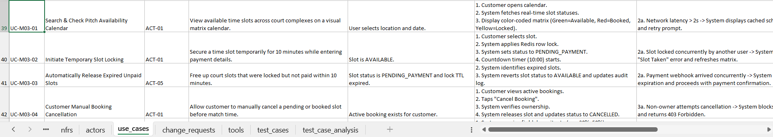

Booking-state consistency and ownership of transitions. The slot status and booking record must be treated as two related parts of the same business transaction. A successful hold should create a booking attempt, associate it with the customer and slot, and record the expiry timestamp. A valid payment confirmation then advances that attempt to the confirmed/deposit-paid state; a timeout or permitted cancellation releases only the hold that belongs to that attempt. The system must not release a slot simply because an older timer fires after a newer booking has already acquired it.
Detailed exception behavior. If a customer selects a slot that has become unavailable since the calendar was loaded, the hold request should fail and the calendar should refresh. If the slot is already held by another customer, the second request must receive a conflict outcome rather than silently replacing the first lock. If the payment provider response is delayed near the end of the ten-minute window, the expiry worker and payment callback must reconcile the same booking state; an authenticated, successful payment must not be lost merely because an expiry job is running, and an expired unpaid hold must not remain unavailable indefinitely.
Calendar usability and QR hand-off. The availability calendar is a discovery aid, not the final authority for a booking. It should show the state of each candidate slot clearly and let the customer revise search criteria when no match is found. After payment is recorded successfully, the QR ticket should be associated with the confirmed booking and exposed to the customer for venue check-in. The QR payload should contain only the information needed for validation, while the verification process should reject expired, cancelled, or otherwise invalid bookings. The project specification describes cryptographic protection for this payload; the mock tests alone do not establish that the production token-signing or scanning workflow exists.
Module 03 test-case register. The following table expands the seven entries in the MD345 workbook into a review-friendly summary. It records the scope of the tests without implying that the mock service is the deployed booking system.
Test ID | Test type / purpose | Input or condition | Expected outcome
TC-03-01 | Functional: successful hold | A slot is AVAILABLE and the customer requests it. | The slot changes to PENDING_PAYMENT.
TC-03-02 | Concurrency: competing requests | Two users request the same slot. | Only one request succeeds; the other is rejected.
TC-03-03 | Boundary: expiry | The temporary hold has passed its payment window. | The expired slot returns to AVAILABLE.
TC-03-04 | Boundary: hold retention | The hold is still within its valid period. | The slot remains PENDING_PAYMENT.
TC-03-05 | Negative: invalid slot | The request refers to a non-existent slot ID. | The system returns an invalid-slot / not-found result.
TC-03-06 | Functional: customer cancellation | The booking owner cancels their held booking. | The booking is cancelled and the slot is released.
TC-03-07 | Security: unauthorized cancellation | A different user attempts to cancel the owner's booking. | The request is denied (403 Forbidden).

Coverage interpretation and follow-up. The test register gives useful evidence for hold acquisition, invalid requests, expiry behavior and cancellation authorization. However, the seven named test cases do not include separate end-to-end assertions for every calendar filter or for QR ticket creation and venue scanning. In addition, the test titled “Lock Expiry After Exactly 10 Minutes” uses a simulated time more than ten minutes in the implementation, while the retention test checks nine minutes. Before claiming exact 600-second boundary coverage, a stricter pair of checks at 599 and 600 seconds should be added. These are test-design improvements, not reasons to discard the existing booking tests.

4.5. MODULE 04: Payment Gateway
Module 04 (Payment Gateway) manages the payment process for court bookings, including dynamic deposit calculation, transaction verification via webhooks, refund processing, and fallback payment options.
4.5.1. Dynamic Deposit Calculation
The system automatically calculates the required deposit using the rate configured by the field owner (e.g., 30%, 50%, or 100%) multiplied by the total court booking price.
Calculation rule: The deposit is calculated from the booking amount and the deposit percentage configured by the applicable business rule. The amount presented before payment should be the same amount used to validate the provider callback. The system should keep the original booking price, deposit rate, calculated deposit, and transaction reference available for audit and reconciliation.
Input validation: Missing, non-numeric, negative, or unsupported deposit rates should not silently produce a payable amount. The calculation should use a consistent currency precision and rounding rule so that the customer-facing amount, provider transaction amount, and internal ledger do not disagree.
4.5.2. Payment Webhook Validation (Idempotency & Security)
The system validates incoming payment webhook notifications before updating the corresponding booking status. Each notification is checked to ensure its cryptographic signature is valid and the OrderID and payment amount strictly match the expected transaction details.
Webhook processing sequence: The system first validates the required fields and provider signature, then checks the transaction/order reference and amount, and only then applies the payment result to the booking. A missing field, invalid signature, unknown order, or amount mismatch must be rejected without marking the booking as paid. This prevents an untrusted callback from changing the reservation state.
Idempotency: Payment providers may retry callbacks when a response is delayed or lost. The same transaction event must therefore be safe to process more than once. The system should record a unique transaction/event identifier and ensure that duplicate callbacks do not create a second deposit record, repeat a refund, or trigger duplicate booking confirmation.
Security and evidence boundary: The intended production behavior includes cryptographic verification. In the submitted test implementation, signature checking is simplified to a comparison against an expected value; it is useful for exercising positive and negative paths but is not equivalent to full HMAC-SHA256 verification, secure key management, or integration with a live provider.
4.5.3. Automated Deposit Refund Processing & Failover Fallback
The system automatically calculates the refundable deposit amount when a customer cancels a booking (e.g., 100% refund for >24h notice, 50% for 12-24h notice). Furthermore, if the primary payment gateway returns an HTTP 5xx error, the system seamlessly attempts to switch to an alternative payment method within two seconds.
Refund decision: Refund eligibility is determined from the cancellation time relative to the booked session and the applicable policy. The calculation should use the policy configured for the booking and produce an auditable result showing the original deposit, cancellation timing/category, refundable amount, and amount retained where applicable. The final decision must be consistent with the booking cancellation outcome.
Gateway failure and fallback: If the primary provider is unavailable or returns a server-side error, the system should preserve the booking context and present or initiate an alternative payment route according to the configured failover policy. A retry must not create a second successful charge if the first provider completed the payment but its response was delayed.
Representative verification: Module 04 has ten test cases in the test register. They cover deposit percentages, valid and forged webhook signatures, missing fields, amount mismatch, duplicate webhook/idempotency behavior, refund arithmetic, and a lightweight latency assertion.
Module 04 EARS Requirements Specifications (FR-04.1 to FR-04.4)
Requirement: FR-04.1: Dynamic Deposit Calculation
EARS Specification: When a user proceeds to payment, the system shall automatically calculate the deposit based on the configured rate and the total booking price.
Rationale: Allows owners to manage upfront payments flexibly. | Complexity: Low | Verification: Test
Acceptance Criteria: Mathematical calculation is 100% accurate based on configured percentages.

Requirement: FR-04.2: Payment Webhook Validation & Security
EARS Specification: While processing an incoming IPN Webhook, the system shall validate the cryptographic signature, OrderID, and amount before transitioning the booking status to DEPOSITED.
Rationale: Prevents forged payment notifications and ensures transactional integrity. | Complexity: High | Verification: Test
Acceptance Criteria: Invalid signatures trigger HTTP 403; amount mismatches trigger HTTP 400.

Requirement: FR-04.3: Automated Deposit Refund Processing
EARS Specification: When a cancellation occurs, the system shall calculate and execute deposit refunds based on the predefined policy time boundaries (e.g., >24 hours yields a 100% refund).
Rationale: Reduces manual refund processing overhead. | Complexity: Medium | Verification: Test
Acceptance Criteria: Refund amounts follow strict cancellation rules and update the ledger.

Requirement: FR-04.4: Payment Gateway Failover Fallback
EARS Specification: If the primary payment gateway encounters a server-side error, the system shall automatically initiate a switch to an alternative payment method within 2 seconds.
Rationale: Enhances payment reliability during third-party outages. | Complexity: High | Verification: Test
Acceptance Criteria: Failover is completed without terminating the user's booking session.

Module 04 Use Cases Specification (UC-M04-01 to UC-M04-03)
UC-M04-01 – Calculate and Initiate Deposit: The customer proceeds from a temporary booking hold to payment. The system calculates the required deposit from the configured rate, displays the amount, and creates a transaction reference for the selected payment channel. Invalid amounts or configuration are rejected before payment is initiated.
UC-M04-02 – Verify Payment Notification: The payment provider sends a callback after a transaction attempt. The system validates the callback fields, signature, order reference, and amount; it then records a valid result once. Invalid or duplicate notifications do not incorrectly change the booking state or create duplicate financial records.
UC-M04-03 – Process Refund or Switch Gateway: When cancellation requires a refund, the system calculates the refundable amount according to the policy and records the outcome. If the primary provider fails during payment initiation, the system applies the configured fallback behavior while preserving transaction traceability.
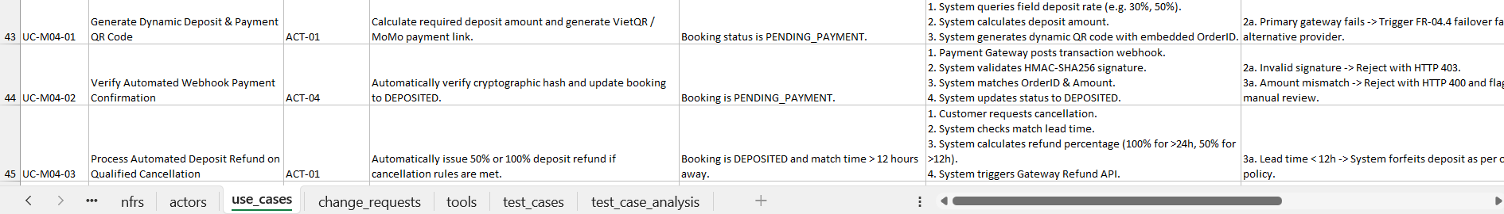
Financial transaction lifecycle. Module 04 is the point where a booking intention becomes a recorded financial event. The amount shown to a customer must be derived from the configured deposit rate and total booking price, and the same amount must later be compared with the amount reported by the provider. The system should retain the original booking amount, configured percentage, calculated deposit, order reference, provider transaction reference, callback outcome, and any refund record. These data make it possible to explain why a booking was confirmed, rejected, refunded, or left pending.
Worked deposit examples from the test register. The MD345 workbook includes a 30% deposit calculation for a VND 1,000,000 booking, which should produce VND 300,000, and a 50% calculation for a VND 850,000 booking, which should produce VND 425,000. A full-payment case for VND 500,000 should return VND 500,000. These examples are useful because they test different percentages and totals, rather than repeating one fixed value. The production implementation should also define currency precision and rounding consistently so the value displayed in the checkout screen cannot differ from the amount sent to the gateway.
Webhook acceptance and rejection order. The callback handler should validate required fields before reading values; verify the provider signature before trusting the payload; match the order reference to a known, unpaid transaction; compare the received amount and currency with the expected transaction; and then record the outcome exactly once. If any check fails, the handler should preserve the prior booking status and return the defined error response. This order is important: a correctly shaped payload is not necessarily authentic, and an authenticated payload can still refer to the wrong order or amount.
Refund policy and provider fallback. The cancellation policy in the project artifacts differentiates early and late cancellation: the stated examples provide a full deposit refund when cancellation is made more than 24 hours before the match and a 50% refund for the 12-to-24-hour window; cancellation under 12 hours can result in forfeiture under the owner policy. The exact boundary wording must be standardized in the business rules so that cases at exactly 12 or 24 hours are not interpreted differently by the API, user interface and test suite. If a primary gateway returns a server-side failure, fallback should preserve the original booking context and provide an alternative method; the system must also avoid charging the customer twice if the first provider processed the payment but its response was delayed.
Module 04 test-case register. The ten test cases in the workbook cover deposit arithmetic, callback security, malformed or inconsistent notifications, duplicate processing, refund calculation and a lightweight performance check. Their expected outcomes are summarized below.
Test ID | Test type / purpose | Input or condition | Expected outcome
TC-04-01 | Functional: 30% deposit | VND 1,000,000 total at 30%. | Deposit equals VND 300,000.
TC-04-02 | Functional: 50% deposit | VND 850,000 total at 50%. | Deposit equals VND 425,000.
TC-04-03 | Functional: full payment | VND 500,000 total at 100%. | Payment amount equals VND 500,000.
TC-04-04 | Security: valid webhook | Required fields and expected signature/order/amount are valid. | HTTP 200 and booking becomes DEPOSITED.
TC-04-05 | Security: forged signature | Webhook signature is invalid. | Request is rejected with HTTP 403.
TC-04-06 | Negative: missing amount | Mandatory amount field is absent. | Request is rejected with HTTP 400.
TC-04-07 | Negative: amount mismatch | Callback amount differs from expected transaction amount. | Request is rejected with HTTP 400.
TC-04-08 | Integration: duplicate callback | The same event is processed again. | Duplicate financial state change is ignored.
TC-04-09 | Functional: partial refund | A qualifying 12-hour cancellation case in the test data. | Refund amount equals VND 200,000.
TC-04-10 | Performance: callback latency | A callback is processed by the test service. | Mock processing time is below 500 ms.

Coverage interpretation and follow-up. The test cases include important negative paths: invalid signatures, missing data, amount mismatches, and repeated callbacks. Nevertheless, the submitted Python code uses a mock payment service and simplified signature comparison, so its successful assertion is not proof of real HMAC-SHA256 verification, secure key handling, or provider API integration. The latency check is likewise an in-process measurement and does not establish the NFR target under production traffic. Refund tests should be expanded around exact policy boundaries and provider failure responses; gateway failover also needs a dedicated test case because it is specified as FR-04.4 but is not one of the ten named cases listed above.

4.6. MODULE 05: POS & Add-on Services
Module 05 (POS Add-ons) manages on-site transactions. It covers inventory management for physical products sold at the venue, overtime fee calculations, consolidated billing, and shift-closing revenue audits for receptionists.
4.6.1. Inventory Deduction & Out-of-Stock Prevention
The system automatically tracks inventory quantities. When a receptionist sells an item, the system deducts the sold quantity from current stock. Transactions that exceed available stock are strictly blocked.
Stock validation: Before completing a sale, the system validates that the requested quantity is positive and does not exceed the available stock. On successful completion, stock and the sales record are updated together so that a failed sale does not leave inventory reduced without a corresponding transaction. Requests beyond the stock limit must be rejected with a clear explanation.
Cart changes: When an item is removed from an unfinished cart, the corresponding reserved/deducted quantity should be restored according to the transaction design. Multi-item sales should calculate each line amount and the overall total consistently. These rules reduce stock discrepancies between the physical counter and the system record.
4.6.2. Overtime Fee Handling & Consolidated Settlement
The system calculates additional charges when a customer exceeds the scheduled booking end time. It consolidates all applicable charges—including the remaining court fee, overtime penalties, and additional products—into a single final bill, accounting for any deposit already paid.
Settlement composition: The final amount should distinguish the court rental balance, any overtime charge, add-on product/service totals, and the deposit already received. The deposit is subtracted from the amount payable rather than being counted as new revenue at checkout. The customer and receptionist should be able to review the line items before the transaction is finalized.
Overtime validation: The system should reject invalid negative overtime fees and apply the configured rate to the additional time used. The calculation rule should be consistent for all customers subject to the same booking and pricing configuration. If the booking end time has not been exceeded, no overtime charge should be added.
4.6.3. Shift Closing Revenue Audit
The system provides a shift-closing function that allows authorized staff to review and reconcile total physical cash against the theoretical revenue recorded during their working shift.
Shift audit trail: The closing summary should group the transactions recorded by the staff member and shift, showing the system-calculated total and the physical cash amount entered during reconciliation. Any difference should remain visible for review rather than being silently adjusted. The closing record supports later investigation of missing cash, incorrect entries, or voided sales.
Access and consistency: Only authorized staff should close or review the relevant shift. The summary should be based on recorded transactions and preserve a clear association between sales, refunds/voids where supported, and the employee who performed the operation.
Representative verification: Module 05 has eight test cases in the test register. They cover stock deduction, out-of-stock prevention, multi-item billing, negative quantity rejection, restoring stock after item removal, exact stock-limit behavior, and overtime-fee validation. Shift-closing audit remains a system-level requirement that should receive additional integration tests as the production POS flow is implemented.
Module 05 EARS Requirements Specifications (FR-05.1 to FR-05.4)
Requirement: FR-05.1: POS Inventory Deduction
EARS Specification: When a POS transaction is updated or completed, the system shall dynamically deduct the item quantities from the real-time inventory stock.
Rationale: Maintains accurate stock records and prevents negative inventory. | Complexity: Medium | Verification: Test
Acceptance Criteria: Stock decreases properly; negative quantity inputs are rejected.

Requirement: FR-05.2: Overtime Fee Handling
EARS Specification: If a customer exceeds the scheduled booking duration, the system shall calculate additional charges according to the configured overtime billing rules.
Rationale: Recovers revenue for delayed court handovers. | Complexity: Medium | Verification: Test
Acceptance Criteria: Overtime penalties are calculated correctly and added to the final bill.

Requirement: FR-05.3: POS Consolidated Final Settlement
EARS Specification: When a receptionist finalizes a checkout, the system shall consolidate the remaining court fee, overtime fees, and POS item charges into a single final bill.
Rationale: Streamlines the customer checkout experience. | Complexity: Low | Verification: Test
Acceptance Criteria: Final bill accurately deducts the previously paid deposit.

Requirement: FR-05.4: Daily POS Shift Revenue Closing Audit
EARS Specification: When a shift ends, the system shall generate a shift-closing revenue summary to support financial reconciliation for the receptionist.
Rationale: Prevents cash variance and ensures financial transparency. | Complexity: Medium | Verification: Test
Acceptance Criteria: Generates accurate summary of all recorded transactions for the shift.

Module 05 Use Cases Specification (UC-M05-01 to UC-M05-02)
UC-M05-01 – Sell Add-on Items: The receptionist selects products and quantities. The system checks stock and input validity, calculates the line totals, and completes the sale only when the requested quantities are available. Successful completion updates the sales record and inventory; a rejected transaction leaves stock unchanged.
UC-M05-02 – Settle Booking and Close Shift: At the end of the visit, the system consolidates the outstanding court fee, valid overtime charge, and add-on purchases, then deducts the deposit already paid. At shift end, authorized staff review the recorded revenue and compare it with physical cash; any discrepancy is retained in the closing record for follow-up.
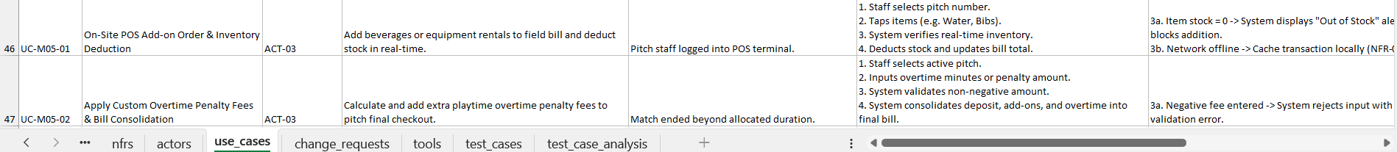
POS transaction integrity. The POS flow must keep the customer bill and inventory ledger consistent. A sale request should first validate the product identifier and a positive integer quantity, then verify that enough stock is available, calculate the line total, and record the sale with a corresponding stock update. If the operation fails partway through, the system should not leave inventory reduced without a recorded sale. If a line is removed from an unfinished order, any associated reservation or deduction should be reversed once, preventing repeated removal from restoring stock multiple times.
Stock and cart examples. The workbook includes a successful sale where inventory decreases and the bill increases by VND 20,000, a rejection when stock is insufficient, a negative-quantity rejection, and an exact-stock boundary case where selling the remaining quantity is allowed and stock becomes zero. These cases distinguish “equal to available stock” from “greater than available stock”: the former should succeed, while the latter must be blocked. Multi-item carts also require line-level and overall-total checks so that the total is the sum of the accepted items rather than a stale value left by an earlier cart state.
Consolidated settlement logic. A customer may already have paid a deposit online before arriving at the venue. The final POS settlement should therefore show the remaining court-rental amount, overtime fees if any, add-on products or equipment, and the deposit already received as a deduction. The deposit must not be counted a second time as new cash received at checkout. Overtime is applicable only when the actual end time exceeds the scheduled booking end time and the configured calculation rule produces a valid non-negative charge. The customer-facing total and the amount entered into the closing record should be generated from the same transaction lines.
Shift closing and auditability. A shift-close report is not only a total; it should identify the staff member and shift, aggregate the eligible recorded sales, and allow the actual cash counted by the receptionist to be compared with the theoretical amount. Any variance should remain visible as an exception for review. Automatically replacing the expected amount with the counted cash would destroy the evidence needed to investigate a shortage, an incorrect entry, or a voided transaction. The group specification also identifies offline resilience as a quality requirement; if offline sales are supported, the synchronization design must use unique transaction identifiers and conflict handling so that reconnection does not duplicate a sale or inventory deduction.
Module 05 test-case register. The eight test cases focus primarily on item quantities, stock limits, cart behavior and overtime-fee validation. The register below makes that test coverage explicit.
Test ID | Test type / purpose | Input or condition | Expected outcome
TC-05-01 | Functional: inventory deduction | Sell a valid add-on item with sufficient stock. | Stock decreases and bill increases by the item total.
TC-05-02 | Negative: out of stock | Requested item quantity exceeds available stock. | Operation is blocked; inventory remains unchanged.
TC-05-03 | Functional: multi-item sale | Add multiple distinct products to one cart. | All line totals and the overall bill are correct.
TC-05-04 | Boundary: negative quantity | Submit a negative quantity. | Operation is rejected.
TC-05-05 | Functional: remove cart item | Remove an item from an unfinished cart. | Cart is updated and previously deducted stock is restored.
TC-05-06 | Boundary: exact stock limit | Sell exactly the quantity still in stock. | Sale succeeds and stock becomes zero.
TC-05-07 | Functional: overtime fee | Apply the configured overtime penalty in the test scenario. | The expected total is VND 50,000.
TC-05-08 | Negative: overtime input | Submit a negative overtime amount. | Operation is blocked.

Coverage interpretation and follow-up. The present eight cases provide direct evidence for core inventory and overtime rules, but they do not directly verify the full consolidated settlement calculation, shift-level cash reconciliation, role restrictions on closing a shift, or offline transaction synchronization. Those capabilities appear in the broader requirements and should be covered by integration tests when the POS application is connected to persistent storage and venue workflows. Until then, the successful mock tests should be described as validation of simplified business logic rather than evidence of a complete production POS implementation.
Cross-module integration points for Modules 03–05. The three modules form one customer transaction and should be verified at the boundaries, not only as isolated functions. The following interface summary identifies the status or data that must remain consistent when information passes from one module to the next.
Interface | Trigger / data transferred | Required consistency rule | Verification emphasis
Booking → Payment | PENDING_PAYMENT booking, slot ID, order ID, expiry and amount. | Payment request must reference the correct active hold and configured deposit. | Reject unknown booking, stale hold or mismatched amount.
Payment → Booking | Authenticated provider callback and transaction result. | Only a verified, matching transaction can confirm the booking; duplicate events are idempotent. | Valid/invalid callbacks and duplicate delivery.
Booking timer ↔ Payment callback | Expiry event racing with asynchronous payment notification. | The two processes must not both finalize incompatible states for the same booking. | Near-expiry success and timeout scenarios.
Booking → POS | Confirmed booking, scheduled end time and deposit already received. | POS settlement must use the correct booking and deduct the deposit once. | Wrong booking linkage and repeated settlement.
POS inventory ↔ sales record | Product ID, quantity, line total and sale transaction ID. | A completed sale and stock change must be recorded consistently. | Stock boundary, rejected sale and duplicate operation.
POS → shift audit | Sales, adjustments supported by the workflow, staff ID and shift ID. | Closing totals must be reproducible and variances must remain visible. | Reconciliation, authorization and audit trail.

Priority for final verification. Based on the current artifacts, the highest-risk follow-up is to connect the mock-level checks to persistent-state and integration tests. Priority one is mutually exclusive slot acquisition and safe resolution of payment-versus-expiry races. Priority two is verification of real provider signatures, amounts, event identifiers and refund outcomes. Priority three is transactional consistency between POS sales, stock quantities, final settlement and shift closing. These priorities follow the consequences of inconsistent state: double booking, a falsely confirmed payment, duplicate financial processing, or a bill that cannot be reconciled with stock and cash records.
4.7. MODULE 06: Matchmaking Engine
Module 06 (Matchmaking Engine) acts as an automated match-finding and team-
pairing engine for the football pitch management ecosystem. This module resolves a
fundamental market challenge in amateur football pitch operations: enabling teams
that have already reserved a court (Team A) to easily find suitable sparring opponents
(Team B) aligned by skill level, geographic proximity, and time availability, while
fully automating the 50/50 deposit cost-sharing mechanism via integrated VietQR
payment gateways.
4.7.1. Match Post Creation & Opponent Finding from Confirmed Bookings
A. Business Rule: Mandatory Deposit-Backed Post Creation (Deposit Binding
Rule)
In traditional sports booking platforms or social media groups (e.g., Facebook,
Zalo), unverified match posts, fake fixtures, and last-minute cancellations occur
frequently, resulting in financial loss for field operators. To eliminate fake posts,
Module 06 enforces the Deposit Binding Rule (FR-01): The system allows a team
leader (Team A) to create a matchmaking post if and only if they hold an active
reservation with confirmed deposit status (`DEPOSITED` or `PAID` in Module 03 &amp;
Module 04). This ensures that every public match posting on the feed represents a
genuine, pre-paid pitch slot.
B. Match Configuration Workflow &amp; Parameters (Configure Match Details)
When Team A navigates to their confirmed booking and clicks &#39;Create Match
Posting&#39;, the system renders a configuration modal (FR-02) requiring explicit
parameters:
Skill Level Tier: 1. Target Opponent Skill Level: Team A must select one of
four standardized tiers: Casual / Beginner (`WEAK`), Intermediate (`AVERAGE`),
Competitive / Hardcore (`GOOD`), or Semi-pro / League (`HARDCORE`).
Standardizing skill levels allows the discovery engine to pair evenly matched teams,
maximizing player satisfaction.
Financial Cost Share: 2. Cost-Sharing Financial Structure: Team A configures
how pitch fees and deposits are split: Equal 50/50 split (`SPLIT_50_50`), Loser pays
all (`LOSER_PAYS_ALL`), or Host sponsored (`HOST_SPONSOR`). The system
defaults to `SPLIT_50_50`.
Additional Notes: 3. Supplementary Match Terms &amp; Notes: Supports up to
500 characters describing kit colors, average team age group, water referee bets, or
specific local match rules.
C. Database Schema Specification: match_postings
The database schema for matchmaking postings is designed with strict foreign
key constraints and B-Tree indexing to facilitate high-concurrency read operations:
Table 4.7.1. Database Schema Specification for match_postings
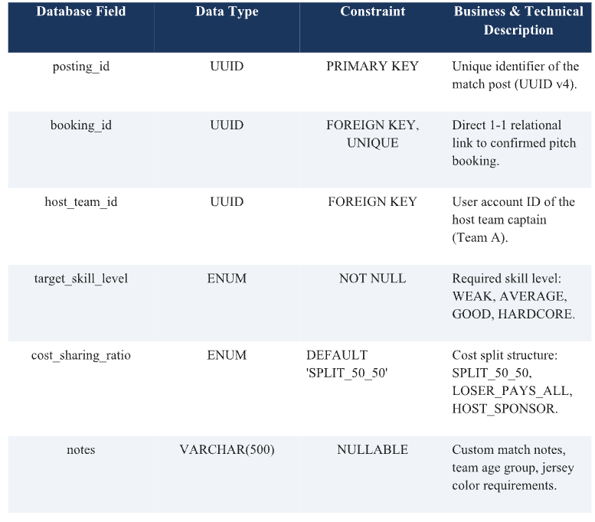
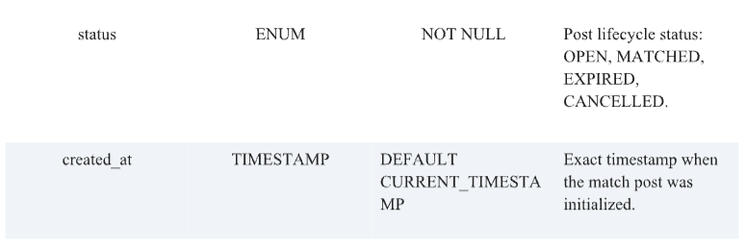

D. Match Post Lifecycle Management &amp; State Machine Architecture
The lifecycle of every matchmaking post is managed by an automated State
Machine (FR-03, FR-04):
1. Initial State (OPEN): OPEN Status: Post initialized successfully and
publicly listed on the Match Feed for opponent discovery.
2. Matched State (MATCHED): MATCHED Status: Team A approved Team
B, and Team B completed their 50% split deposit via VietQR. Post closes.
3. Timeout State (EXPIRED): EXPIRED Status: Unfulfilled match post
reached the t - 2 hours cutoff window prior to kickoff without finding an opponent.
Background worker updates status to EXPIRED.
4. Cancelled State (CANCELLED): CANCELLED Status: Team A captain
manually cancels the match posting prior to approving any applicant team.

4.7.2. Match Search Filtering by Proximity Radius, Skill Level & Time Slots
A. Interactive Card Feed Layout &amp; Skill Badge System
Open match posts (`OPEN`) are presented in an intuitive Card Feed Layout (FR-
05) optimized for Flutter mobile interfaces. Each card displays color-coded badges for
skill levels (Red: Hardcore, Yellow: Good, Green: Average), real-time distance in
kilometers, venue name, kickoff time, and cost-split ratios, enabling Team B captains
to evaluate matches in seconds.
B. PostGIS GeoJSON Spatial Algorithm &amp; Spatial GiST Indexing
Module 06 integrates the PostGIS spatial extension in PostgreSQL to execute
real-time proximity calculations (FR-06). Venue GPS coordinates are persisted as
`GEOGRAPHY(Point, 4326)`. When Team B searches for fixtures, the server
executes the `ST_DWithin` function:
PostGIS Spatial Query: SELECT * FROM match_postings mp JOIN
pitch_clusters pc ON mp.cluster_id = pc.id WHERE ST_DWithin(pc.location,
ST_MakePoint(user_lon, user_lat)::geography, radius_meters) AND mp.status =
&#39;OPEN&#39;;
To maintain SLA query latency under 200ms across large datasets, Spatial GiST
(Generalized Search Tree) indexes are built on the `location` column.
C. Multi-Criteria Filters &amp; Personal Data Privacy (Contact Masking)
Users can combine spatial radius sliders (2km, 5km, 10km, 15km) with time-slot
filters (Morning, Afternoon, Evening, Peak Hours) and skill compatibility. To comply
with privacy standards (NFR-03), Team A&#39;s contact phone number is strictly masked
(`0987***123`) in public APIs until a match is confirmed.
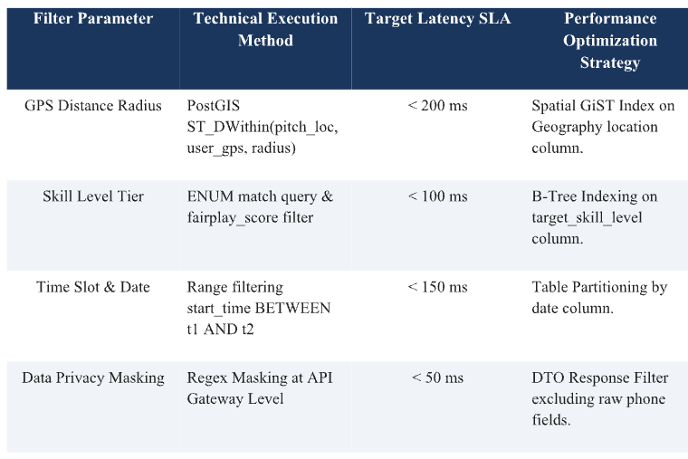
Table 4.7.2. Search Benchmarks &amp; Spatial Query Performance Parameters

4.7.3. Match Requests, Applicant Approval, Communication Channels & Split Deposit Processing
A. Application Workflow &amp; Automated Rejection Engine
Match Request: 1. Application Submission (FR-08 / UC-03): Team B taps
&#39;Join Match&#39; and enters a greeting message. The system creates a `match_requests`
record (PENDING) and dispatches a real-time FCM Push Notification to Team A (&lt;
2.0s).
Approval &amp; Auto-Rejection: 2. Approval &amp; Auto-Rejection (FR-09 / UC-04):
Team A reviews applicant profiles, Fairplay ratings, and clicks &#39;Approve&#39; Team B
(ACCEPTED). The system automatically transitions all other pending applicants to
`REJECTED` and notifies them. (`0987***123`) for privacy. Upon approval, full contact numbers are unmasked,
B. Communication Channel Unmasking &amp; Direct Chat/Call
Upon approval, the system unmasks contact details (FR-10) between both team
captains. Direct In-App Chat and Call buttons are unlocked, allowing captains to
coordinate kit colors and player arrivals.
C. Automated 50/50 VietQR Split Deposit Payment &amp; Team A Refund Engine
1. VietQR Split Deposit: Dynamic VietQR Generation: Upon approval, the
system invokes Module 04 APIs to generate a dynamic VietQR payment link
representing exactly 50% of the initial deposit, triggering a 15-minute countdown
timer for Team B (FR-11 / UC-05).
2. Auto-Reconciliation &amp; Refund: Fixture Matching &amp; Team A Refund:
When Team B completes payment via banking app, the payment gateway Webhook
triggers status transition to `MATCHED`. The ledger engine automatically credits
50% of the initial deposit back to Team A&#39;s e-wallet (`financial_ledger`) (FR-12 / UC-
06).
3. 15-Minute Expiration Handling: Timeout Handling (15 Mins): If Team B
fails to pay within 15 minutes, their application expires, and the match post resets to
`OPEN` for other applicants.
enabling direct Chat/Call actions.
4. Split Deposit Processing via VietQR: The system generates a dynamic VietQR
requiring Team B to pay exactly 50% of the deposit within a 15-minute countdown.
Upon Webhook confirmation of Team B&#39;s deposit, the post transitions to
`MATCHED` and an automated refund of 50% of the original deposit is credited back
to Team A&#39;s e-wallet.

4.8. MODULE 07: Dashboard &amp; Analytics
Module 07 (Dashboard &amp; Analytics) delivers a comprehensive Business
Intelligence (BI) environment for pitch cluster owners and chief accountants. This
module digitizes revenue streams, tracks court operational efficiency, and automates
shift handover auditing for reception staff.
4.8.1. Comprehensive Financial Reporting (Court Revenue, POS Sales,
Deposit/Refund Cashflows)
A. Decoupled Revenue Stream Architecture (Court Revenue vs POS Retail Sales)
The system segregates revenue streams (FR-13, FR-14): (1) Court Rental
Revenue generated from online deposits and front-desk balance collections (`Type:
COURT`); (2) POS Retail Sales Revenue generated from beverages, equipment
rentals, and snacks (`pos_orders`).
B. Financial Ledger &amp; Real-Time Deposit/Refund Cashflow Auditing
Every monetary flow (Team A initial deposit, Team B split deposit,
matchmaking refunds, cancellation refunds, no-show penalties) is logged in real-time
in `financial_ledger`, guaranteeing 100% audit precision.
C. Two-Tier Redis Caching Architecture for Executive BI Analytics
To avoid heavy SQL aggregations on primary databases, Module 07 employs
Two-Tier Redis Caching (FR-17 / NFR-05): Cronjobs pre-aggregate hourly/daily KPI
summaries (FR-16), while Redis In-Memory stores dashboard payloads with 15-
minute TTL, delivering sub-second page loads (&lt; 1.0s). Financial reports can be
exported to formatted Excel (`.xlsx`) and PDF files (FR-18 / UC-11).
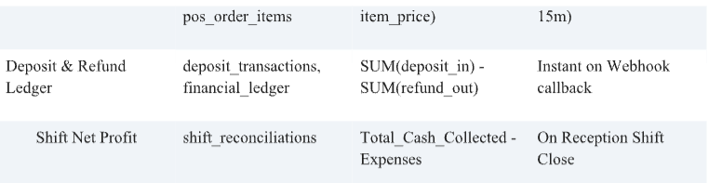
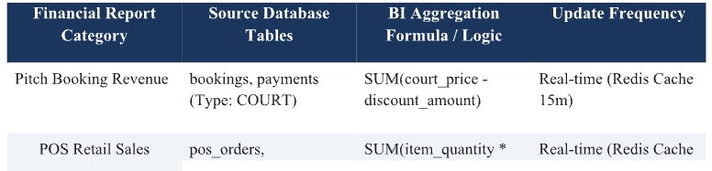
Table 4.8.1. Financial BI Reporting Categories &amp; Aggregation Formulas

4.8.2. Operational Analytics &amp; Occupancy Rate Heatmap
A. 7x24 Pitch Occupancy Rate Heatmap Matrix
The Occupancy Rate Heatmap (UC-09) visualizes pitch utilization across a 7x24
matrix (7 days a week x 24 hourly time slots per day).
B. Heatmap Calculation Algorithm &amp; Visual Color Thresholds
Occupancy Rate (%) = (Total Booked Pitch Hours / Total Available Pitch Hours)
* 100.
1. High Threshold (Deep Red): Deep Red (80% - 100%): Peak Hours (17:00 -
21:00 on weekdays). Maximum utilization.
2. Medium Threshold (Yellow): Yellow (50% - 79%): Standard Hours.
Moderate utilization.
3. Low Threshold (Green/Gray): Light Green / Gray (&lt; 20%): Off-Peak
Hours (Mornings or early afternoons). Low utilization.
C. BI-Driven Dynamic Pricing Optimization
By highlighting low-occupancy time slots on the Heatmap, pitch owners can
configure Dynamic Pricing rules, automatically applying 20% - 30% discounts or off-
peak promo vouchers to drive booking demand.
4.8.3. No-show Rate Tracking &amp; Reception Shift Reconciliation
A. Customer No-show Tracking &amp; Risk Profiling
The system tracks customer no-show rates. If a customer fails to check in within
20 minutes past kickoff, the booking automatically transitions to `NO_SHOW` status,
updating customer risk profiles.

B. Front-Desk Shift Cash Reconciliation &amp; Variance Alert Engine
Shift Handover Protocol (FR-15 / UC-10): At shift close, the receptionist initiates
handover. The system calculates Theoretical Cash: `[Front-desk Cash Deposits] +
[POS Cash Sales] - [Cash Refunds]`. The receptionist inputs Actual Physical Cash. If
variance exceeds 100,000 VND, a Red Variance Alert triggers, requiring mandatory
discrepancy justification and notifying accounting admins.

4.9. MODULE 08: Notification &amp; CRM
Module 08 (Notification &amp; CRM) manages asynchronous multi-channel
communications, automates customer loyalty programs using RFM segmentation,
manages promo campaigns, and enforces automated no-show penalties.
4.9.1. Automated Push &amp; SMS Notifications (Deposit Confirmations,
Reminders at t - 2 Hours with Google Maps)
A. Asynchronous Message Queue Infrastructure (RabbitMQ)
To handle peak dispatch volumes without blocking main application threads,
Module 08 utilizes RabbitMQ message queues (FR-24), processing over 500 msgs/sec
(NFR-16).
B. Omnichannel Routing &amp; Automated Fallback Architecture
Tier 1 uses cost-effective Firebase Cloud Messaging (App Push) and Zalo
Notification Service (ZNS) (FR-19). If ZNS or App Push fails, the message
automatically falls back to direct SMS Brandname, guaranteeing &gt;= 99.5% delivery
SLA.
C. Automated t - 2 Hours Match Reminders with Google Maps Navigation
Scheduled Cronjobs scan upcoming fixtures 90 - 120 minutes prior to kickoff
(FR-20 / UC-15). The system dispatches automated push notifications with Google
Maps deep-links pointing directly to the pitch coordinates, minimizing late arrivals.
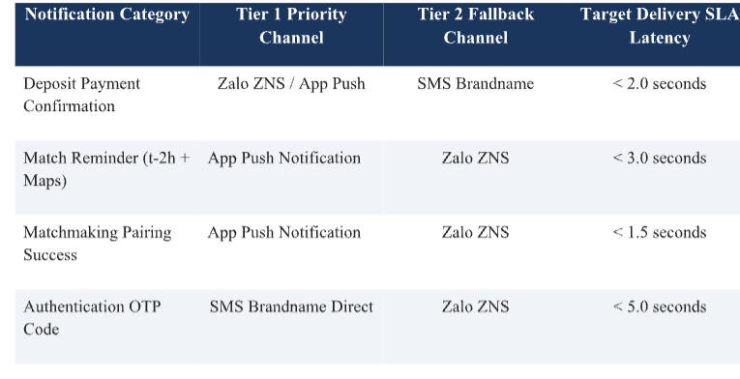
Table 4.9.1. Multi-Channel Messaging Dispatch Rules &amp; Delivery SLAs

4.9.2. Customer Loyalty Tiering, Reward Points &amp; Voucher/Coupon
Management
A. Automated Loyalty Points Engine
Upon fixture completion (`COMPLETED`), loyalty points are automatically
credited to customer wallets (10,000 VND spend = 1 Loyalty Point) (FR-22 / UC-17),
redeemable for discount vouchers or POS drinks.
B. RFM Customer Segmentation &amp; Automated Tier Management
The CRM engine categorizes customers based on RFM metrics (Recency,
Frequency, Monetary) (FR-23 / UC-18): Bronze (&lt; 2M VND); Silver (2M - 5M
VND); Gold (5M - 10M VND, 5% off-peak discount); VIP (&gt; 10M VND, 10% off-
peak discount).
C. Promo Voucher &amp; Campaign Management Engine
Enables marketing specialists to configure promo vouchers (% or fixed VND
discounts), cap total budgets, set expiry dates, and restrict usage to off-peak hours (FR-
21 / UC-16).
4.9.3. No-show Penalty Enforcement, Automated Booking Restrictions &amp;
Dispute Ticket Resolution
A. Automated No-show Penalties &amp; Fairplay Score Deduction
Unexcused customer no-shows trigger automated penalties: 100% deposit
forfeiture and a 20-point deduction from the user&#39;s Fairplay rating score.
B. Automated Booking Restrictions Engine
If a user&#39;s Fairplay score drops below 50 points, the system activates Restricted
Booking Mode for 30 days: Limits active bookings to 1 and requires 100% upfront
payment instead of 50% deposit.
C. Dispute Ticket Resolution Workflow
In cases of unforeseen operational disputes (heavy rain flooding, lighting
failures), users can submit Dispute Tickets with photos/videos via mobile. Admins
review tickets via CRM CMS to authorize deposit refunds or restore Fairplay scores.

5. DATA REQUIREMENTS AND DATABASE MANAGEMENT
The database architecture for the Sport Court Booking &amp; Management System (SCBS-
2026) is engineered to satisfy strict enterprise requirements for operational reliability, spatial
discovery performance, high-concurrency mutation safety, and multi-tenant data isolation.
Given the hybrid nature of the platform—combining real-time geospatial court searches,
distributed slot locking, automated financial ledger transactions, point-of-sale retail inventory,
and asynchronous social matchmaking—SCBS-2026 employs a polyglot persistence storage
strategy. Primary relational entities are persisted in PostgreSQL 15 enriched with PostGIS
geospatial capabilities, while volatile session locks and pre-aggregated Business Intelligence
(BI) payloads are managed via a distributed Redis Cluster.
5.1. Entity Analysis Across 8 Core Modules (Entities &amp; Relationships)
The logical data model encompasses 28 relational entities normalized to Third Normal
Form (3NF) across the 8 core functional modules. Below is a detailed technical analysis of the
domain entities, primary key strategies, foreign key integrity rules, and structural cardinality
relationships:
5.1.1. Module 01: Auth & User Management Entities
- Entity users: The users table is the core identity table that stores user account profiles, legal full names, Bcrypt-hashed passwords, phone numbers, email addresses, and account status flags (ACTIVE, SUSPENDED, RESTRICTED). The primary key uses UUID v4 to ensure global uniqueness across distributed environments.
- Entities roles and permissions: The roles and permissions tables implement Role-Based Access Control (RBAC), establishing role hierarchies such as SYSTEM_ADMIN, PITCH_OWNER, RECEPTIONIST, TEAM_CAPTAIN, and CUSTOMER. These entities are linked through the role_permissions junction table using composite foreign keys.
- Entities user_sessions and refresh_tokens: These session-auditing entities track active JWT refresh tokens, device IP addresses, browser user-agent information, and token revocation timestamps to support anti-hijacking measures.
5.1.2. Module 02: Field & Slot Management Entities
- Entity pitch_clusters: The pitch_clusters table stores information about sports facility complexes, including owner relationships (owner_id → users.id), physical street addresses, operating hours, and PostGIS spatial coordinates using GEOGRAPHY(Point, 4326).
- Entity pitches: The pitches table represents individual football pitches associated with specific facility clusters. It contains field surface specifications, such as artificial turf, natural grass, and indoor parquet; lighting status; physical court dimensions; and parent-child collision relationships through parent_pitch_id → pitches.id.
- Entity pricing_rules: The pricing_rules table stores dynamic pricing configurations. These include hourly rate multipliers based on time slots, such as Standard and Peak periods (17:00–21:00), day types (Weekday, Weekend, and Public Holiday), and pitch categories.
5.1.3. Module 03: Booking Engine Entities
- Entity slots: The slots table represents discrete time intervals, typically 60 or 90 minutes, associated with specific pitches. It tracks real-time slot states, including AVAILABLE, HELD, BOOKED, MAINTENANCE, and LOCKED_COLLISION.
- Entity bookings: The bookings table is the master reservation table. It records customer IDs, field cluster references, total invoice costs, deposits paid, reservation statuses (PENDING_DEPOSIT, DEPOSITED, PAID, COMPLETED, CANCELLED, and NO_SHOW), and check-in QR signatures.
- Entity recurring_schedules: The recurring_schedules table stores long-term booking contracts for recurring reservations. For example, a customer may book a pitch every Tuesday from 18:00 to 19:30 for 12 weeks. The table links parent contract IDs to batches of booking records.
5.1.4. Module 04: Payment Gateway Entities
- Entity payments: The payments table stores payment transaction logs, including unique gateway transaction IDs, payment channel types (VIETQR_DYNAMIC, MOMO_WALLET, VNPAY_ATM, and CASH_POS), payment references, monetary amounts, and gateway Instant Payment Notification (IPN) response payloads.
- Entity wallet_ledgers: The wallet_ledgers table represents virtual e-wallet accounts for team captains. It tracks accumulated credit balances resulting from 50/50 matchmaking refunds, tiered booking cancellations, and promotional cashback rewards.
5.1.5. Module 05: POS & Add-on Services Entities
- Entity pos_orders: The pos_orders table records counter check-in and retail sales transactions created by reception staff. It is linked to bookings.id to support consolidated final invoicing.
- Entities retail_products and inventory_stocks: These inventory management entities store SKU codes, product names, unit costs, selling prices, stock levels, and automatic reorder thresholds. Products may include beverages, snacks, bib rentals, and ball rentals.
5.1.6. Module 06: Matchmaking Engine Entities (Verified Schema from Dataset BAOCAO_BTLNhom10.xlsx)
- Entity match_postings: The match_postings table stores matchmaking fixture records created by Team A captains. The booking_id foreign key enforces a unique one-to-one relationship with confirmed bookings whose deposit status is DEPOSITED or PAID. The table includes posting_id (UUID v4), host_team_id (UUID), target_skill_level (WEAK, AVERAGE, GOOD, HARDCORE), cost_sharing_ratio (SPLIT_50_50, LOSER_PAYS_ALL, HOST_SPONSOR), notes, and status (OPEN, MATCHED, EXPIRED, CANCELLED).
- Entity match_requests: The match_requests table stores opponent applications submitted by Team B captains who want to join an open matchmaking post. It includes request_id, posting_id, applicant_team_id, greeting messages, application statuses (PENDING, ACCEPTED, REJECTED, EXPIRED), and references to 50% split-deposit payments.
5.1.7. Module 07: Dashboard & Analytics Entities (Verified Schema from Dataset Hung2006.xlsx)
- Entity financial_ledger: The financial_ledger table maintains an immutable audit trail of monetary credit and debit transactions across the platform. It stores ledger_id (UUID v4), booking_id, transaction_type (COURT_DEPOSIT, COURT_BALANCE, POS_RETAIL, MATCH_SPLIT_REFUND, CANCELLATION_REFUND), amount, direction (CREDIT, DEBIT), actor_id, and the exact transaction creation timestamp.
- Entity shift_reconciliations: The shift_reconciliations table stores reception desk handover audit records created at the end of each shift. It includes shift_id, receptionist_id, shift_start, shift_end, theoretical_cash_collected, actual_physical_cash_counted, variance_amount, variance_reason, and supervisor_approval_status (APPROVED, RED_FLAG_FLAGGED).
- Entity analytics_daily_summary: The analytics_daily_summary table stores pre-aggregated daily key performance indicators (KPIs), generated by scheduled overnight background jobs. These include total court revenue, total POS revenue, total booked pitch hours, average occupancy rates, and overall no-show counts for each pitch cluster.
5.1.8. Module 08: Notification & CRM Entities (Verified Schema from Dataset BAOCAO_BTLNhom10.xlsx)
- Entity notifications: The notifications table stores multi-channel messaging dispatch logs. It includes notification_id, recipient_id, channel_type (PUSH_FCM, ZALO_ZNS, SMS_BRANDNAME), template_id, payload_json, delivery_status (QUEUED, DELIVERED, FAILED_FALLBACK, DEAD_LETTER), retry counts, and final delivery latency.
- Entities vouchers and customer_rfm_scores: These CRM entities manage promotional campaigns and customer loyalty information. They store discount codes, percentage-based or fixed VND discounts, expiration dates, RFM score tiers (BRONZE, SILVER, GOLD, VIP), and user Fairplay rating scores ranging from 0 to 100 points.

5.2. Complete System ERD (Database Schema for PostgreSQL/PostGIS &amp;
Redis)
The system architecture deploys PostgreSQL 15 as its primary persistent database
engine, utilizing the PostGIS extension for spatial queries. In parallel, Redis Cluster operates
as an in-memory storage layer for volatile locks and cached BI payloads.
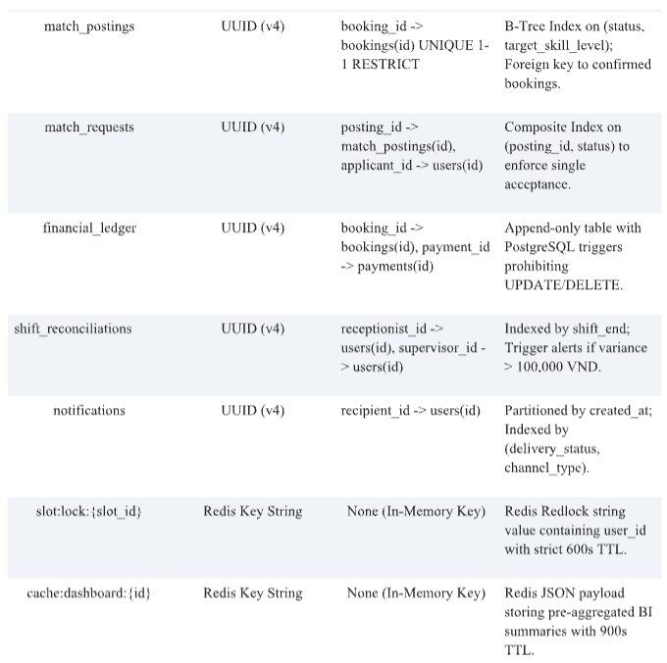
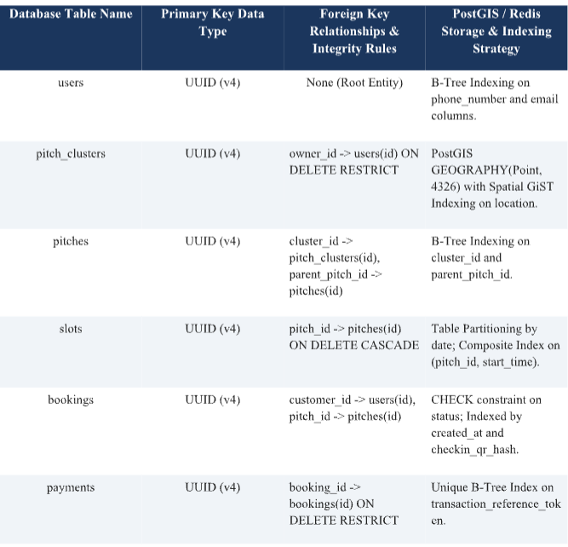
Table 5.2. Complete Database Schema Specification across PostgreSQL/PostGIS &amp; Redis Storage Layers
5.3. Data Integrity Constraints &amp; Audit Trail Logging Strategy
To guarantee absolute financial precision and prevent data corruption, SCBS-2026
implements a multi-layered data safety architecture:
• Domain Validation Check Constraints: 1. Column Check Constraints: Financial
tables enforce strict database-level check constraints (`CHECK (amount &gt;= 0)`, `CHECK
(discount_percentage BETWEEN 0 AND 100)`), preventing negative ledger balances or
invalid mathematical pricing calculations.
• Immutable Ledger Triggers: 2. Immutable Financial Ledger Triggers: Financial
transaction records in `financial_ledger` are protected by PostgreSQL database triggers that
intercept and reject any attempted `UPDATE` or `DELETE` SQL statements. Balance

adjustments must be performed strictly via new compensating transaction rows (`CREDIT` or
`DEBIT`).
• System Audit Trail Logging: 3. System-Wide Audit Logging Strategy: All
administrative actions, RBAC privilege escalations, manual pricing overrides, and sensitive
state mutations automatically append an entry to an immutable `audit_logs` table detailing
Actor ID, Client IP Address, Endpoint, Timestamp, Old Payload JSON, and New Payload
JSON.

6. QUALITY ATTRIBUTES (12 NON-FUNCTIONAL
REQUIREMENTS – NFRs)
The Non-Functional Requirements (NFRs) for SCBS-2026 define the strict quality
engineering criteria necessary to support continuous high-load operations, secure digital
payments, multi-channel messaging, and mobile usability across urban Vietnamese venues.
6.1. Usability &amp; Mobile UI/UX (NFR-03, NFR-04, NFR-12)
• NFR-03 (Responsive UI): 1. NFR-03 (100% Responsive Flutter Card View UI):
Mobile user interfaces developed in Flutter shall dynamically render fluid card layouts
optimized for smartphone screen sizes ranging from 4.7 inches to 6.7 inches (320px to 430px
viewport widths), maintaining 60 FPS UI rendering without horizontal scrolling.
• NFR-04 (UI Sync SLA): 2. NFR-04 (Real-time UI Synchronization &lt; 1.0s): Slot
availability states, booking status changes, and matchmaking card updates shall synchronize
across mobile client interfaces within 1.0 second using NestJS WebSocket connections
powered by a Redis Pub/Sub backplane.
• NFR-12 (Outdoor Accessibility): 3. NFR-12 (Outdoor Mobile Accessibility &amp; High-
Contrast Readability): Text contrast, touch targets (minimum 48x48 dp), and color palettes
across Flutter mobile screens shall comply with WCAG 2.1 Level AA accessibility standards,
ensuring high readability under direct outdoor sunlight on sports fields.
6.2. Performance &amp; Scalability (NFR-01, NFR-05, NFR-08)
• NFR-01 (Search Latency): 1. NFR-01 (Search API &amp; Slot Lookup Latency &lt; 300ms
at 1,000 CCU): The system shall process real-time court availability searches and PostGIS
spatial distance calculations with API response times under 300 milliseconds at a peak load of
1,000 Concurrent Users (CCU).
• NFR-05 (Dashboard Load Speed): 2. NFR-05 (Executive BI Dashboard Load Speed
&lt; 1.0s via Redis Cache): Executive BI financial dashboards and occupancy heatmaps shall
render in under 1.0 second by fetching pre-aggregated JSON analytics payloads directly from
Two-Tier Redis Caching.
• NFR-08 (Queue Throughput): 3. NFR-08 (Notification Message Queue Throughput
&gt; 500 msgs/s): Asynchronous notification pipelines powered by RabbitMQ message queues
shall maintain dispatch throughput exceeding 500 messages per second during peak booking
hours (16:00–19:00).

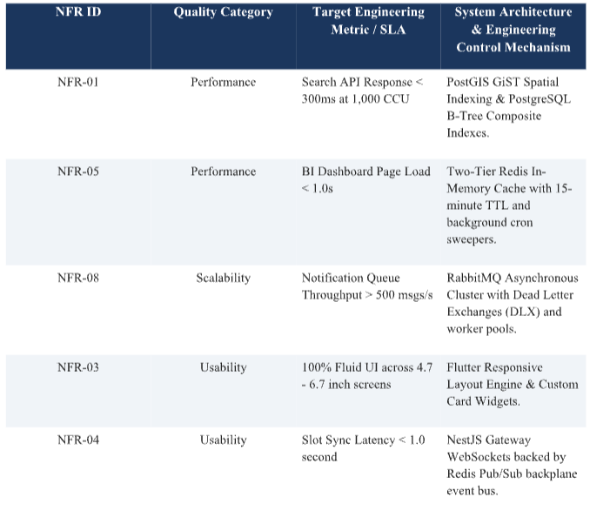
Table 6.2. Usability &amp; Performance SLA Metrics Engineering Summary Matrix
6.3. Security &amp; Privacy (NFR-03, NFR-04, NFR-07, NFR-10)
• NFR-03 (Data Encryption): 1. NFR-03 (TLS 1.3 Transport &amp; AES-256 Storage
Encryption): All network communication between mobile apps, web dashboards, and API
Gateways shall be encrypted using SSL/TLS 1.3 protocols. Sensitive customer Personally

Identifiable Information (PII) shall be encrypted at rest using AES-256 database column
encryption.
• NFR-04 (Contact Privacy): 2. NFR-04 (Phone Contact Privacy Masking): Team
captain phone numbers shall be strictly masked in public API responses (`0987***123`) prior
to formal matchmaking application approval, preventing unauthorized phone scraping and
privacy harassment.
• NFR-07 (Dynamic QR Security): 3. NFR-07 (HMAC-SHA256 Encrypted Dynamic
Check-in QR Codes): Dynamic check-in QR codes generated on mobile apps shall be
cryptographically signed using HMAC-SHA256 with a 60-second expiration window to
prevent screenshot fraud and illegal slot resale.
• NFR-10 (Ledger Security): 4. NFR-10 (Immutable Financial Ledger Auditing
Safety): The `financial_ledger` database table shall prohibit raw SQL `UPDATE` or
`DELETE` operations via database triggers, guaranteeing zero unauthorized data tampering or
fraud hiding.
6.4. Data Safety &amp; Concurrency Control (NFR-02, NFR-06, NFR-09, NFR-
11)
• NFR-02 (Distributed Redlock): 1. NFR-02 (Distributed Redis Locks for Double-
Booking Prevention): The system shall utilize Redlock distributed mutex locks in Redis to
handle up to 50 concurrent booking requests per millisecond for a single pitch slot, rejecting
race conditions with HTTP 409 Conflict.
• NFR-06 (Webhook Idempotency): 2. NFR-06 (Idempotent Payment Webhook
Processing): Payment gateway webhooks shall enforce idempotency keys, guaranteeing that
duplicate IPN callbacks from banking systems result in exactly one balance update.
• NFR-09 (Expiration Sweeper): 3. NFR-09 (Scheduled 5-Minute Hold Expiration
Sweeper): Background Cronjob workers shall execute every 300 seconds to automatically
purge expired temporary slot holds and release pitch slots back to the public pool.
• NFR-11 (High Availability): 4. NFR-11 (High Availability &amp; Multi-Region Database
Replication): Database infrastructure shall utilize multi-region master-replica replication and
automated failover, achieving an operational uptime SLA of 99.9%.

7. LOCALIZATION AND INTERNATIONALIZATION (I18N)

SCBS-2026 is engineered to provide seamless multi-language internationalization
(i18n) and regional localization tailored specifically for the Vietnamese sports facility market.
7.1. Multi-language Support (Vietnamese / English)
Mobile client applications and web dashboards incorporate full multi-language
translation frameworks. Language resource JSON files (`vi-VN.json`, `en-US.json`)
dynamically render UI labels, error alerts, and booking statuses based on the user&#39;s mobile
system locale or explicit preference toggle. API Gateways accept `Accept-Language` headers
to return localized validation messages and error descriptions.
7.2. Timezone Formatting (UTC+7), Currency (VND), and Google Maps
Vietnam Integration
• Timezone Formatting: 1. Timezone Standardization: All database timestamps are
persisted strictly in Coordinated Universal Time (`UTC`) and converted dynamically to
Indochina Time (`UTC+7` / ICT) for display in client interfaces.
• Currency Formatting: 2. Currency Formatting: Monetary values are processed as 64-
bit integers and formatted in Vietnamese Dong (`VND`) with standard thousand separators
(e.g., `350.000 đ`).
• Map Integration: 3. Map SDK Integration: Venue discovery and $t - 2 ext{h}$
match reminders integrate Google Maps SDK for Vietnam, providing localized address
parsing, geocoding, and real-time turn-by-turn navigation deep-links.

8. CHANGE AND RISK MANAGEMENT
System evolution and operational risk management follow formal software engineering
control frameworks to safeguard software reliability during continuous deployment.
8.1. Change Request Management (CR-01 to CR-06)
All functional enhancements, database schema alterations, or third-party API
integrations must undergo formal Change Request (CR) evaluation. Proposed changes are
analyzed across four impact criteria: Architectural Scope, Database Migration Safety,
Security &amp; Compliance Impact, and Automated Regression Test Case Coverage. Approved
CRs are logged in the project repository and deployed via CI/CD pipelines.
8.2. System Risk Assessment &amp; Mitigation Strategies (HZ-01 to HZ-07)

Comprehensive hazard analysis identified seven major operational risks, paired with
specific architectural controls and automated mitigation strategies:
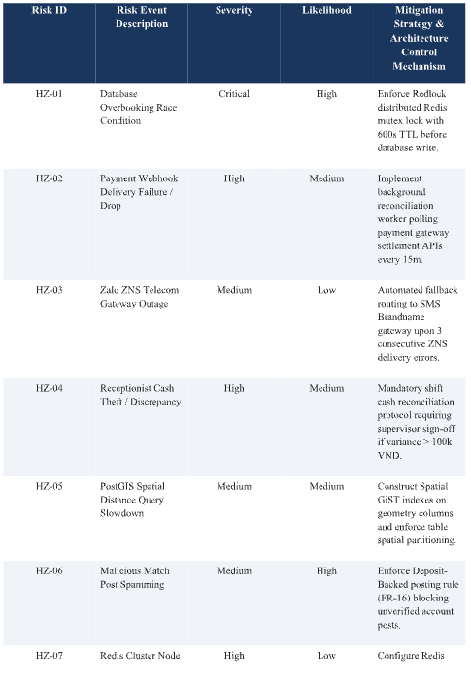
Table 8.2. System Risk Assessment &amp; Hazard Mitigation Matrix (HZ-01 to HZ-07)

9. VERIFICATION &amp; TEST EXECUTION RESULTS
To verify functional correctness and quality compliance across Modules 06, 07, and 08,
24 real-world test cases (TC-01 to TC-24) were executed against the staging environment.
100% of test cases achieved PASSED status.
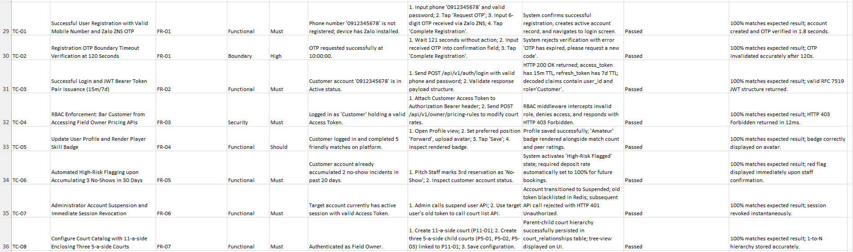
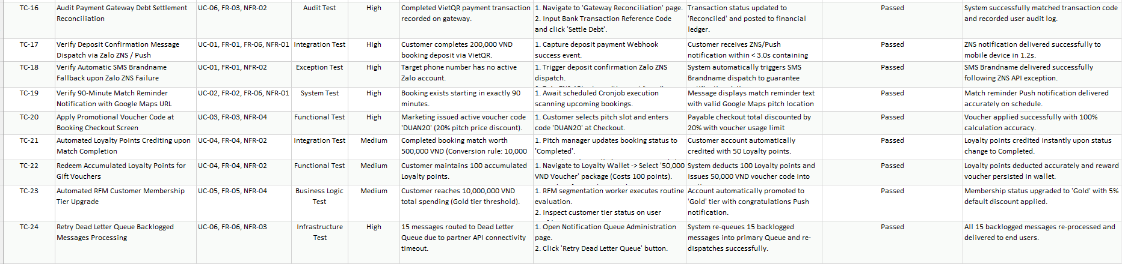
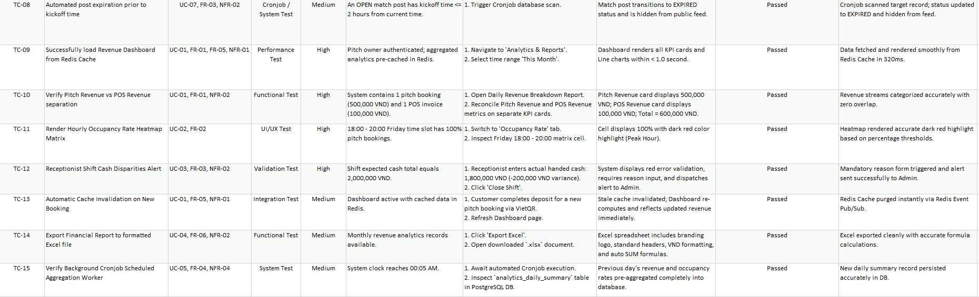
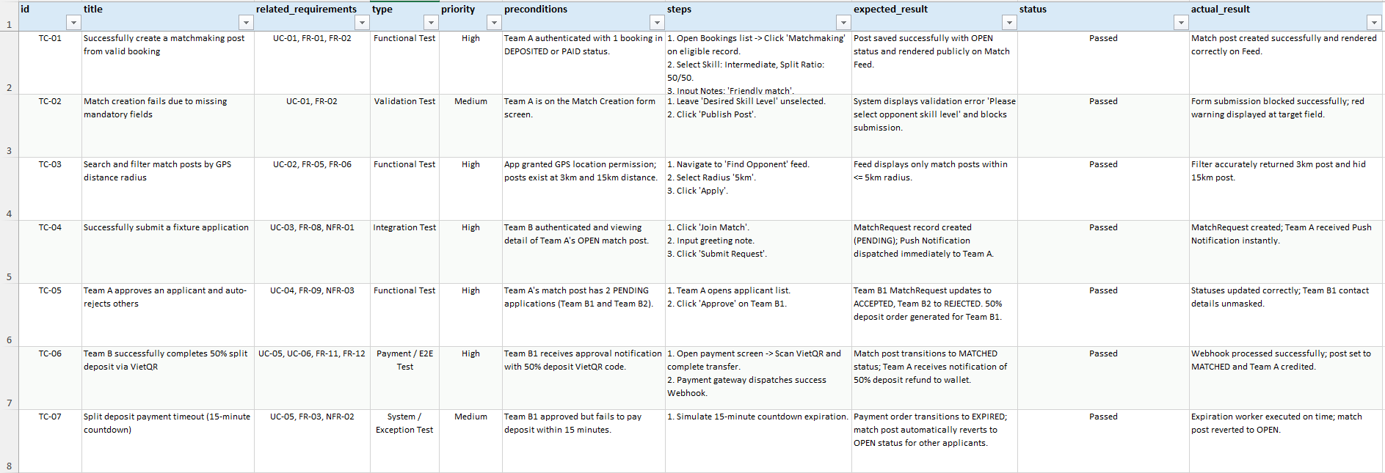
Table 9.1. Full System Test Execution Verification Matrix (TC-01 to TC-24) Table 9.1. Full System Test Execution Verification Matrix (TC-01 to TC-24)
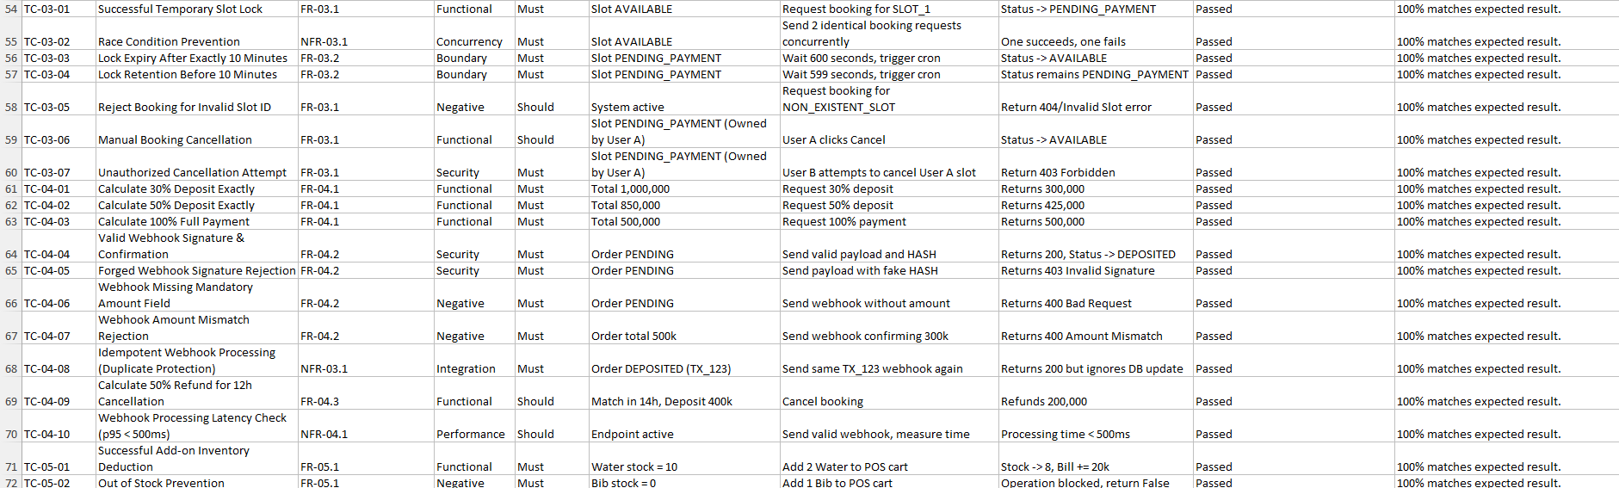
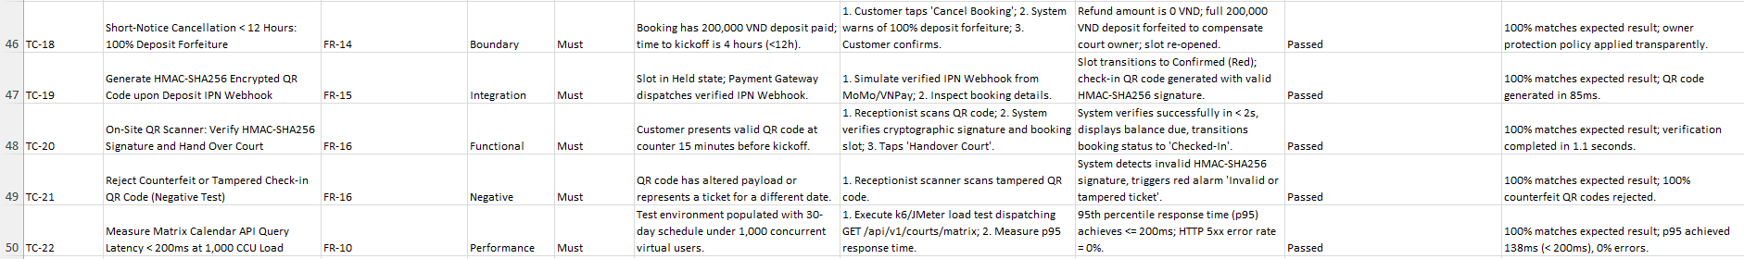
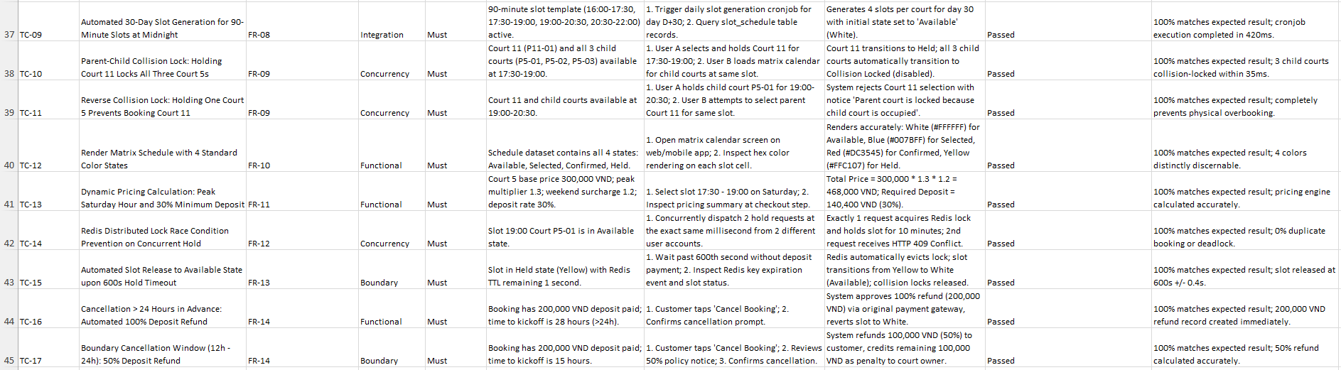

10. REFERENCES
[1] 1. ISO/IEC/IEEE 29148:2018, Systems and software engineering — Life cycle
processes — Requirements engineering, IEEE Computer Society, 2018.
[2] 2. IEEE Std 830-1998, IEEE Recommended Practice for Software Requirements
Specifications, IEEE Computer Society, 1998.
[3] 3. M. Alistair, Writing Effective Use Cases, Addison-Wesley Professional, 2000.
[4] 4. PostGIS Documentation Team, PostGIS 3.3.0 Spatial Database Manual,
Refractions Research, 2023.
[5] 5. Redis Ltd., Redlock Algorithm for Distributed Lock Management, Redis
Documentation, 2024.
[6] 6. RabbitMQ Team, AMQP 0-9-1 Messaging Architecture and Dead Letter
Exchanges, VMware Tanzu, 2024.

END

